II WHO Technical Consultation on
Control of Congenital Chagas disease in non-endemic countries

Murcia, Spain, 9 & 10 October 2018

Presentation scheme – Who, Where, What and How
- Presentation of the group, network and/or institutions:
Expert on Chagas disease, as a representative from Italy are:
- Andrea Angheben, representant of the IRCCS Sacro Cuore Hospital, Centre for Tropical Diseases, Negrar, Verona, with colleagues Paola Rodari, Zeno Bisoffi, Federico Gobbi;
- Lorenzo Zammarchi, Infectious and Tropical Disease Unit, Tuscany Reference Centre of Tropical Diseases, University Hospital Careggi, Florence with colleague Alessandro Bartoloni on behalf of the Tuscany Region and
- Serena Venturelli, Infectious Diseases Unit, ASST Papa Giovanni XXIII, Bergamo with colleague Marco Rizzi.
Every Centre have expertise in diagnosis, case management, prevention of ChD and congenital ChD; the first line drug, Benznidazole is available at all Centres, Nifurtimox is available according to WHO donation.
Regarding these Centres we should mention that they are seeing the most part of Chagas diseases (ChD) cases, in Italy, for a total of around 10% of all estimated cases (600 cases treated out of 6000-12000 cases estimated countrywide). Some other centres are active in Italy on case detection and treatment, namely Lazzaro Spallanzani Hospital, Rome, (Dr Nicastri, Dr Giancola) currently with some projects of active case detection and a recent publication on this topic, and Luigi Sacco hospital which is an University hospital in Milan (Prof Antinori). At La Sapienza University there is a reference lab for parasitological and tropical diseases with an expertise in serological and molecular biology diagnosis of ChD. In Genova, at IRCCS Universitary Hospital San Martino, colleagues are working actively in treatment od ChD cases among the huge Ecuadorian community settled in that area of Liguria Region.
Concerning congenital ChD, Negrar, Florence and the Tuscany Region and Bergamo are currently working on it. Every centre has a protocol of case detection and management; Negrar at institutional level (hospital level) but working on promotion of the screening in the Veneto Region; the centre of Florence introduced on 2008 the serological screening for ChD in LA pregnant women delivering at the Careggi University Hospital, Florence. On 2012 a free screening for ChD in LA pregnant women and the follow-up of newborns from seropositive mothers was formally introduced by law in the Tuscany Region (Regione Toscana, Delibera n°489, 4 Giugno, 2012). This achievement was the result of a long and complex multidisciplinary collaboration between representative of health care services involved (infectious and tropical diseases specialists, paediatricians, neonatologist, midwives, gynecologist and obstetricians, microbiologists, referents of the Tuscany Region ect...). The screening programme has still to be fully implemented and is being uptated (see the results below). ; Bergamo also developed a provincial (sub-regional level) protocol for the prevention of the vertical transmission of ChD by the Inter-Hospital Committee for the Control of Hospital-acquired Infection.
At IRCCS Sacro Cuore Hospital Negrar in a ten years period 131 Latin American (LA) pregnant women have been followed with a total of 131 deliveries. Coverage rate for ChD screening was quite low, 49% but growing across years due to increasing awareness on ChD (very low before 2010). No case of ChD have been detected. The Centre promoted also pregnant women screening at Mangiagalli Clinic in Milan (around 6000 deliveries every year) with a rate of 1,4% of ChD positives and among other LA pregnant women during community sessions of screening (0/18, 0%).
By the end of 2017 (from 2012) around 300 pregnant women have been screened in Tuscany Region for ChD. The estimated coverage is 13% region wide, 71% at the Careggi University-Hospital (the centre who promoted and first implemented the screening); 3 women were ChD positive (1%) and all the six “exposed” children (the three women had one, two and three children respectively) have been followed-up and all were seroreverted after birth.
By the end of 2017, during a period of 3 years in Bergamo Province Hospitals 387 deliveries of 376 women have been followed with a mean screening coverage for ChD of 85.6%; 28 pregnant women resulted ChD positive (8.7% prevalence) giving birth to 29 offsprings (one pair of twins); transmission rate for ChD was 4.3% (1/23) and adherence rate to follow-up was 88.5%.
- Epidemiological context and health system
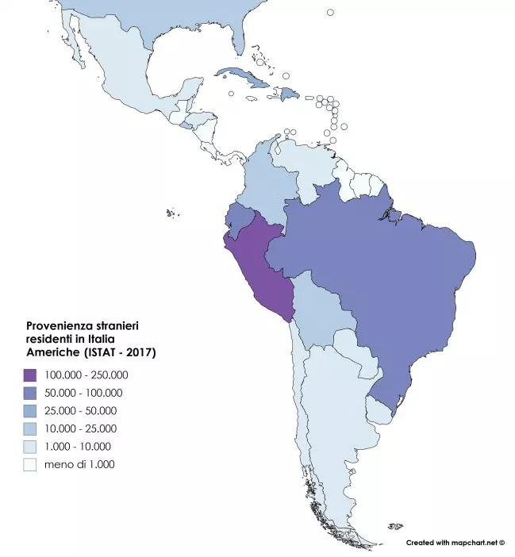
Italy is hosting around 500,000 LA migrants by the end of 2016; the documented migrant are 352824 at 31/12/2016. LA migrants to Italy are mainly from Peru and Ecuador, see figures:
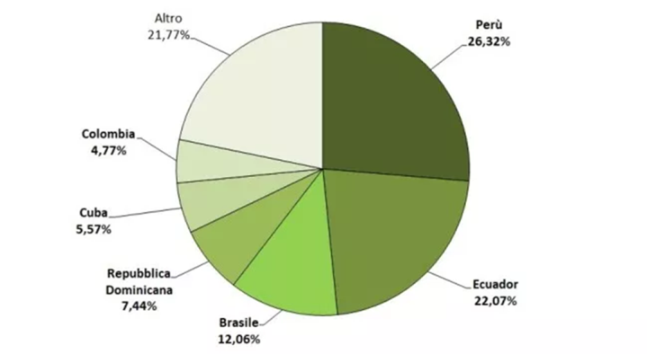

On the base of prevalences of ChD (PAHO) and the 2008 data on migrants in Italy around 6,000-12,000 cases of ChD have been estimated (Angheben et al., Eurosurveillance, 2011).
Estimations on congenital ChD are in course.
LA migration to Italy, as it is for other European countries like Spain is mainly of women living in the 3th to 5th decade of life. Latin Americans in Italy are patchy distributed countrywide with the different communities settled mainly in northern and central Italy and in Rome and its surroundings.
The Italian National Health Service was established on December 23rd, 1978 end approved by 85% of the Parliament (L.833/78). The NHS is founded on the principles of universal coverage, social financing through the use of general taxation and non-discriminatory access to the health care services.
From this Act onward, the history of public health is solidly integrated with the Constitution of our country, with its civil and democratic growth and its economic and social development. This pathway included the creation of the system based on “healthcare trusts” in order to foster efficiency and managerial skills, ensuring provision of healthcare basket benefits (so called LEA, see below) homogenously within the national territory. The Italian National Health System is regionally based and organized at the national, regional, and local levels. Under the Italian constitution, the central government controls the distribution of tax revenue for publicly financed health care and defines a national statutory benefits package to be offered to all residents in every region—the “essential levels of care” (livelli essenziali di assistenza, or LEA). The 19 regions and two autonomous provinces have the responsibility to organize and deliver health services through local health units. Regions enjoy significant autonomy in determining the macro structure of their health systems. Local health units are managed by a general manager appointed by the governor of the region, and deliver primary care, hospital care, outpatient specialist care, public health care, and health care related to social care.
Primary and inpatient care are free at the point of use. Positive and negative lists are defined using criteria related to medical necessity, effectiveness, human dignity, appropriateness, and efficiency in delivery (LEAs). Positive lists identify services offered to all residents; examples include pharmaceuticals, inpatient care, preventive medicine, outpatient specialist care, home care, primary care, and hospice care. Negative lists identify services not offered to patients, such as cosmetic surgery.
Procedures and specialist visits can be prescribed either by a general practitioner (GP) or by a specialist. While there are no user charges for GP consultations and hospital admission stays, patients pay a copayment for each prescribed procedure or specialist visit up to a ceiling determined by law—currently at EUR36.15 (USD48.00).6 Therefore, a patient who receives two separate prescriptions (e.g., for an MRI scan and for a consultation with a gastroenterologist) pays EUR36.15 (USD48.00) for each prescription.
To address rising public debt, in July 2011 the government introduced, along with other economic initiatives, an additional EUR10 (USD13) copayment for each prescription. Copayments have also been applied to outpatient drugs at the regional level, and a EUR25 (USD33) copayment has been introduced for “unnecessary” use of emergency services (although some regions have not enforced this copayment).
ChD is not included in the LEA, therefore affected patient should co-pay part of costs of testing, treatment and follow-up unless hospitalized or part of an institutional program. ChD testing is not provided for free for pregnant women out of the three programs above-mentioned.
The regionalization of the National Health System and the fact the ChD is not included in the LEAs are major obstacles to a national plan of control of ChD vertical transmission. Concerning the other ways of transmission Italy has set up opportune efficacious regulations (blood donors and transplant.
- Legal and normative framework (laws and/or protocols…)
At Provincial (sub-regional) level in Bergamo since 2013 and at Regional level in Tuscany since 2012, operational protocol and an official regulation have been implemented. In Tuscany control of congenital ChD is being regulated by the Tuscany Regional Deliberation n°489, 2012. In the National Sanitary Plan there is no mention on ChD control measures.
In Tuscany according to the protocol of the Delibera n°489, 4 Giugno, 2012 during the first free consultation with a midwife at the public obstetric health service, LA pregnant women should receive a flyer with an information note on ChD for her and for his doctor (general practitioner and/or gynecologist ect...) reporting the recommendation for the free serological test for Trypanosoma cruzi in pregnancy. In case of positivity of ChD test the woman is referred to the Infectious and Tropical Disease Unit, Tuscany Reference Centre of Tropical Diseases, University Hospital Careggi, Florence and the newborn is tested at birth and then followed up at the Infectious Disease Unit, Meyer University Hospital, Department of Health Science, University of Florence, Florence. An updated version of the protocol should be available by the end of this year.
In Bergamo province, ChD testing if offered to all at risk individuals, particularly to women at low cost. In case of positive result, the staging of the disease, treatment and follow-up (visits) is free. The same for the newborn of a positive woman.
In Negrar, the hospital offers free testing, treatment and follow-up to all at risk individuals, particularly pregnant women and women in childbearing age.
- Biomedical and psychosocial strategies
Due to the lack a public health strategy for ChD control and as a consequence of the request of the Bolivian community settled in Bergamo, the interest of the Italian Society of Tropical medicine and International Health (SIMET) and some Institutions (see above) projects and protocols (see above) have been developed since 2008. As a general comment development of these protocols were inclusive, multidisciplinary and long. Actors were public health officers (local or regional), community representatives, institutional representatives form different disciplines (obstetrics, midwives, pediatricians, ID specialists, microbiologists…). The Italian Associacion against ChD (AILMAC, see www.ailmac.it) and some NGOs (MSF, OIKOS etc.) were (and are) active promoters of care protocols.
Two strategies: one is intended to overcome the non-inclusion of ChD in the LEA, therefore is focused on offer of free testing and case management (Negrar, Bergamo, Tuscany, Rome protocols and laws) as it could be if ChD would be included in the LEAs (basket of “essential level of assistance” procedures, approved by MoH and financed by the Regions).
The second strategy is based on education (community level and University level for healthcare students and workers), promotion, active case finding through screening campaigns, community level work. Hereby the different institution have been implemented or are implementing various initiatives. The use of "smart tools" (e.i. App for smartphone) for health care workers involved in the management of pregnant women to remind and facilitate the implementation of ChD screening in pregnancy is being evaluated in Tuscany.
- Laboratory protocol and internal and external quality control
Internal quality control is regularly done at the three laboratories of Negrar, Bergamo and Florence for ChD serologies (and molecular biology at Negrar Centre). For serological diagnosis an esternal quality control have been set up since 2013 in Negrar and Florence thanks to Brazilian PNCQ service. Bergamo Microbiology Department is following external quality control provided by NEQAS.
The protocol of ChD testing is similar to all three above-mentioned facilities: in the clinical practice a high-sensitive test (ELISA or Chemiluminescence) is done, followed by a confirmation test using different technique or antigens. If diagnosis is confirmed, patient is referred to the clinician for ChD work-up and treatment. Polymerase Chain Reaction (PCR) is done at Negrar Centre (in-house based on dr Schijman advise) and Florence. For the newborn all protocols provide a clinical evaluation and testing for ChD (thin and thick blood smear, MHT, PCR when available) at birth and 1-2 months of life, then a serology is done at 9 months and if positive but decreasing titer at 12 months, thus giving the opportunity to clinicians to decide to treat or not to treat the child.
- Information system, epidemiological variables and case notification
In Italy, infectious disease surveillance is based on the Mandatory Reporting System that, pursuant to Ministerial Decree of 15 December 1990 - “Infectious and Transmissible Diseases Information System”, involves the mandatory reporting by doctors of cases of the diseases listed in the same decree. Chagas disease is not in the list. Clinicians can notify a case among the “others” position.
In the framework of congenital ChD control, an information system and case notifications would be advisable. In the programs of Bergamo Province and Tuscany Region a regular report is done thus realizing a surveillance on the issue. This should be duplicated also in the other regions.
A special flow form for some mandatory reporting has been set up in Italy (see meningitis or malaria). A special flow form for congenital ChD could be an interesting tool in this direction.

