BURA CATHOLIC PARISH
DIOCES OF GARISA
P.O BOX 5 70104
BURA TANA, KENYA

4Th SEMI-REPORT OF CHURCH CONSTRUCTION at ST. PAUL, VG. 10 BURA PARISH

Dear Rev/monsignor Fr. Luigi Ginami, president of “SANTINA FOUNDATION”
Receive warm greetings from Bura Catholic Parish, Diocese of Garissa; wishing all the best to you and our donors.
This is the 4th and the last report of St. Paul‘s church construction, in our parish of Bura Tana. And I take the opportunity to express all our gratitude for such a big help you gave to us. On behalf of my fallow parishioners, and myself, I thank you for this support to construct the church in one of our outstation, our people are happy, they have already a worthy place to worship and praise to our Lord; and also we have a memorable place for our martyrs of Garissa terror attack on 2nd april 2015. Every Wednesday we gather to remember them, to pray for them, and to pray for all our benefactors, who helped us to have this wonderful church.
Now I would like to give you the economic report for the last bank deposit you did to our account for our project.
On 26th April 2016, we received the transfer amount of: 1,700.00 EUROS equivalent to 183,702.00 KES. These funds were used to continue the pending works of finishing in ST. PAUL church, Bura Parish. We managed to pay the balance remaining for labor charges, painting works, ceiling work, logos painting, mobilizing refund and others.
OUR NEW CHURCH WAS INAURATED AND ON 2ND MAY 2016.
Church name: ST. PAUL
Parish: “ST. JUDE” BURA CATHOLIC PARISH
Diocese: DIOCESE OF GARISSA “KENYA”
Sponsored by: SANTINA FOUNDATION
Benefited population: 140 FELLOW CATHOLICS

FOLOWING: THE EXPENCES DETAILS TABLE
NO. | ITEMS | CUANTITY | AMOUNT (kes) | COMMENTS
 | paint for walls | 300 lts | 24,350.00 | paint only
 | gloss paint (oil) for skirting | 10 cans 4lts a/u | 5,080.00 | paint only
 | miscellaneous for painting |  | 3,400.00
 | Painting, (labor charges.) |  | 13,500.00
 | 3rd. payment labor charges |  | 157 ,000.00 | Balance remaining from 1st. of 18,000.00 kes & 2nd. Of 75,000.00 kes, Deposit
 | logos making |  | 12,000.00
 | ceiling for rooms |  | 12,460
 | fuel for mobilization |  | 7,700.00
 | negative balance from 3rd Report |  | 18,311.00
 | TOTAL EXPENSES |  | 253,801.00
 | TOTAL RECEIVED |  | 183,702.00
 | negative balance |  | -70,099.00

TOTAL RECEIVED 183,702.00
TOTAL EXPENDED 253,801.00
BALANCE: - 70,099.00
NOTE___ This report is closed with a negative balance of 70,099.00 Kes = 650.00 EUROS
- All the negative balances (debts to other accounts) were taken up to the next reports as expenses.
- In case if positive balances were added as income. So this last report has included all the balances negatives and positives to reach the final amount as negative balance.
With our greatest gratitude to you, SANTINA FOUNDATION , the president, all directives and all our donors; we commend ourselves to your prayers specially for our community ST. PAUL, and for all the people who suffer because the difference of faith. And we assure you our constant prayers for you and all the people members of SANTINA FOUDATION.
MAY GOD BLESS YOU
Fr. Ernesto Contreras Gonzalez
Parish priest

REVERENDO Y QUERIDO MOSNSENYOR Luigi Ginami, gran amigo y misionero en Bura tana Kenya, la tierra banyada y ferilizada con la sangre de los MARTIRES. RECIBE UN CORDIAL SALUDO DESDE ESTAS BELLAS TIERRAS DE MISION, AQUI TE RECORDAMOS CON MUCHO CARINO Y APRESIO, Y TODOS LOS MIERCOLES DE CADA SEMANA, VEMOS UN NOMBRE HERMOSO DIBUJADO EN LA PAREDE DE NUESTRA CASA DE ORACION, "SANTINA" Y RECORDAMOS SU AMOR POR LOS SUFRIDOS Y ELEVAMOS UNA ORACION POR MARTIRES, VICTIMAS DEL TERROR Y POR EL ALMA DE TU MAMITA CUYO NOMBRE ES EL EMBLEMA NUESTROL LOGO '" FUNDACION SANTINA"

QUIERO PEDIR PERDON A TI PRINCIPALMENTE Y A TODOS LOS DIRECTIVOS DE LA INSTITUCION, POR EL ATRASO DE MI ULTIMO REPORTE DEL PROYECTO DE LA IGLESIA EN NUESTRA PARROQUIA, LAENTO MUCHO HABER CAUSADO INCONVENIENCIAS EN TUS REPORTES COMO PRESIDENTE DE ESTA INSTITUCION QUE CON MUCHO AMOR NOS AYUDA A EVANGELIZAR.

EN ESTE EMAIL TE ADJUNTO EL REPORTE ECONOMICO DEL ULTIMO ENVIO VANCARIO QUE NOS HICISTE LLEGAR, FUERON 1700.00 EUROS, SE GASTARON 650 EUROS MAS, PERO ESTAMOS FELICES Y AGRADECIDOS POR TAN GRANDE GENEROSIDAD PARA CON NOSOTROS.

RUEGO A DIOS TODO MARCHE BIEN CONTIGO Y QUE PRONTO ORGANICES OTRO VIAJE MISIONERO Y NOS VISITES EN BURA TANA. MI PARROQUIA ES TU PARROQUIA, MI MISION ES TU MISION,

GRACIAS NUEVAMENTE Y ESPERO EN DIOS PODAMOS SEGUIR EN CONTACTO.

DIOS TE BENDIGA SIEMPRE.

Fr. Ernesto Contreras Gonzales (M.F.M.)

Receipt of expenses for the last funds of 183,702.00 kes = 1700 euros.

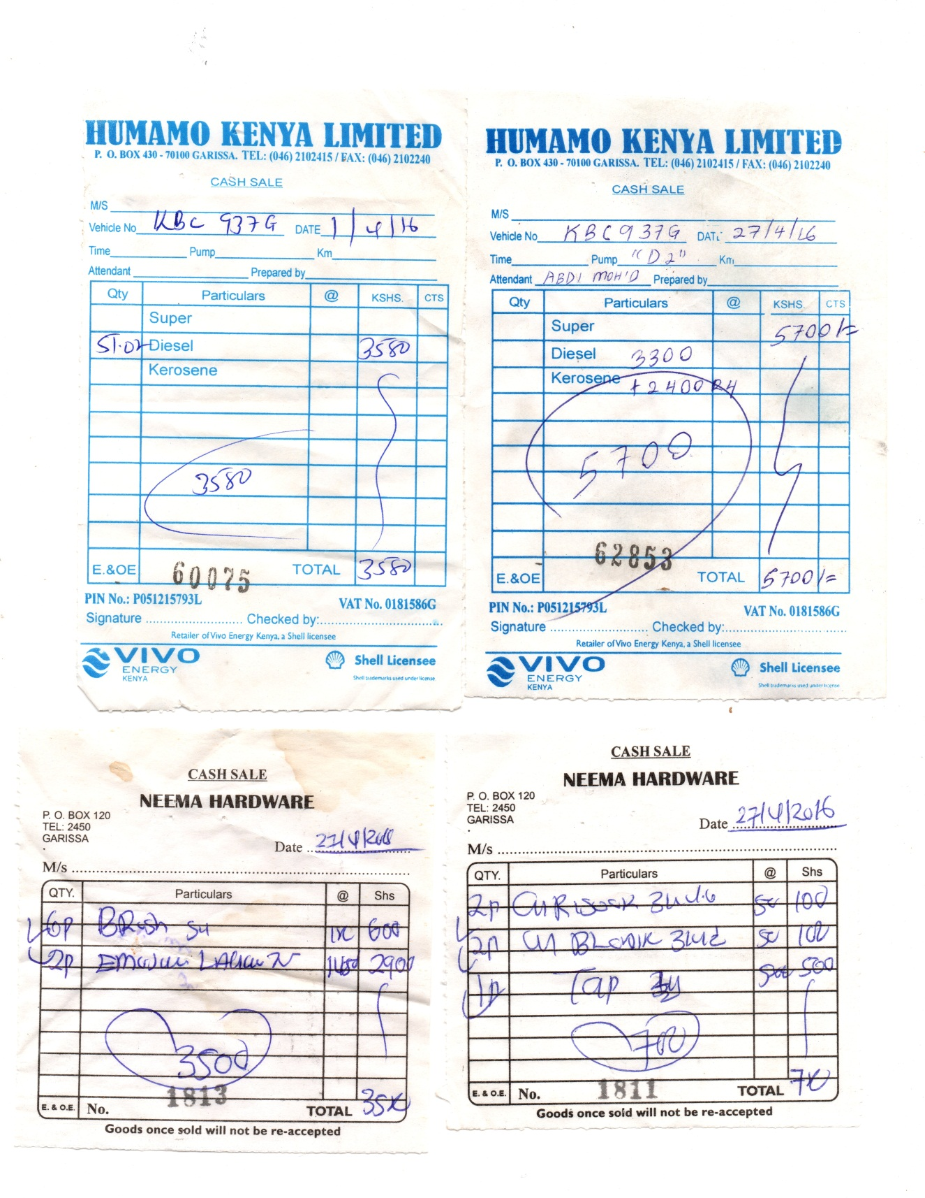
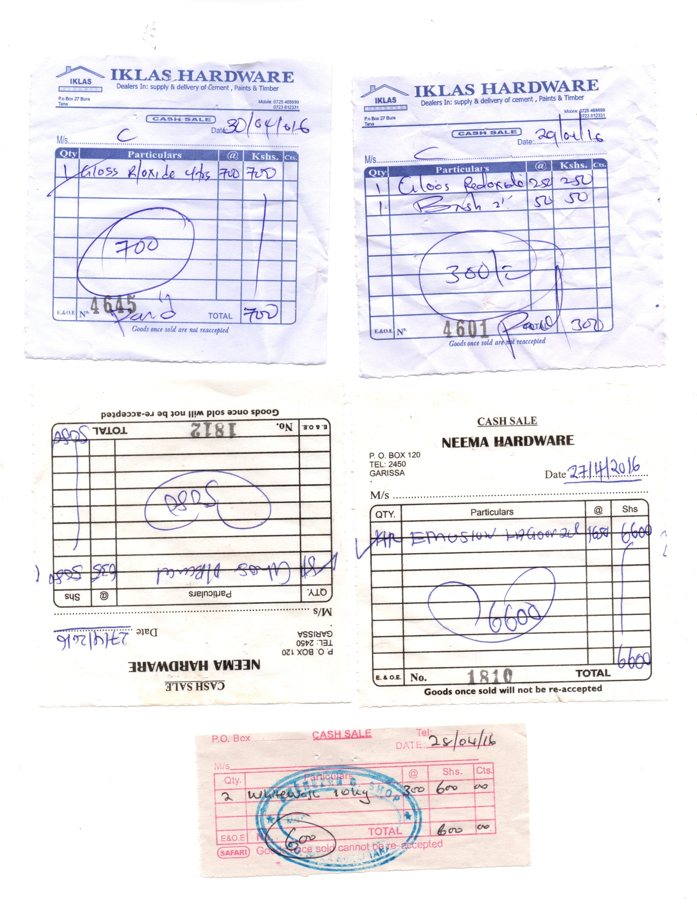
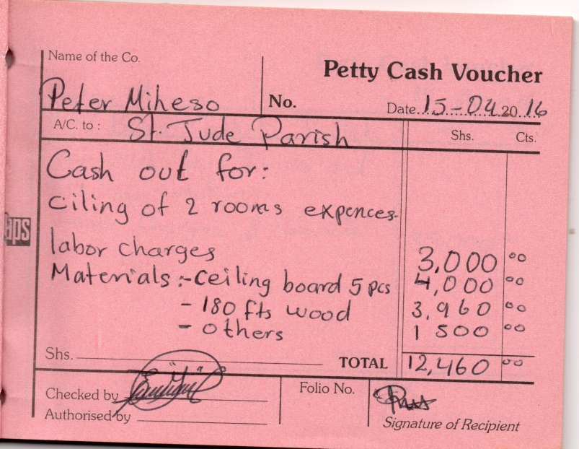
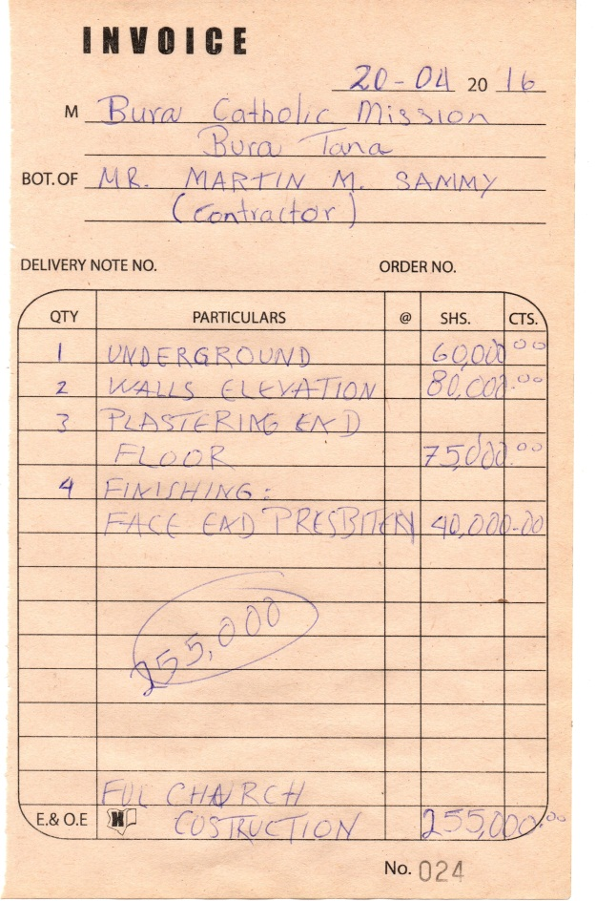

NOTE_____ the amount written in the receipt is different to the one is written in the table report, because the contractor decided to leave some amount as a donation for the project.

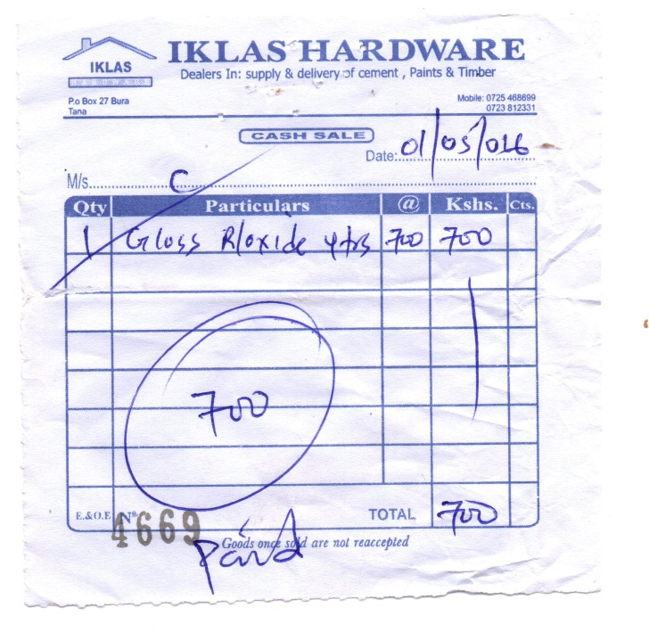

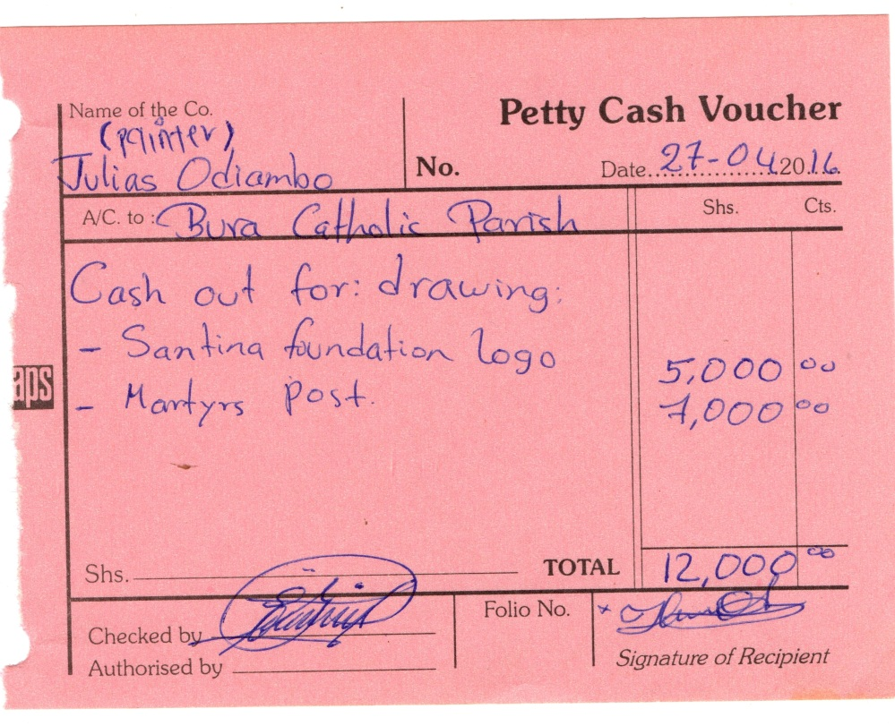
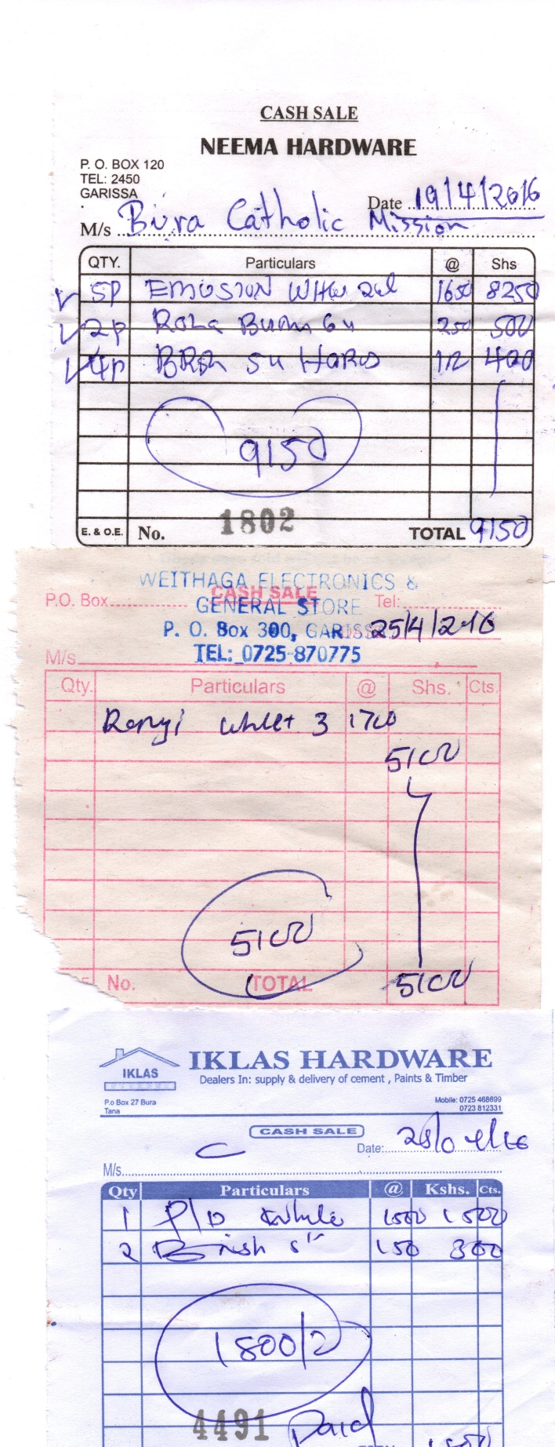

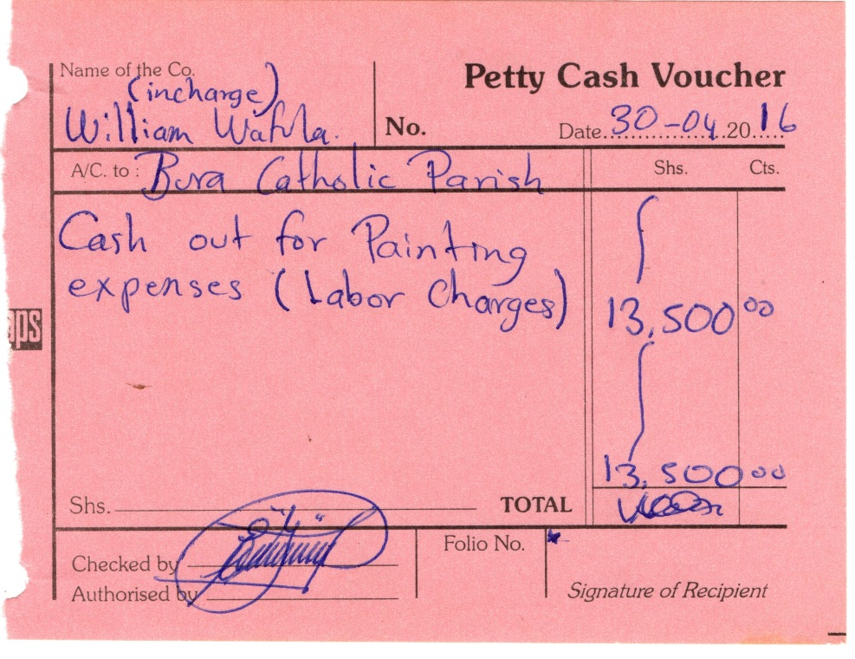

PICTURES OF THE LAST FACE WORK OF OUR CHURCH IN HONOR OF THE MARTYRS

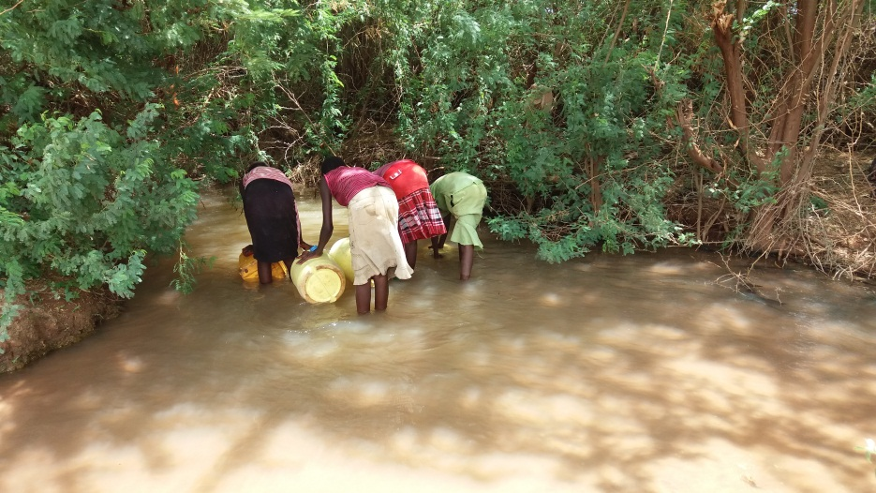
fetching water for the construction

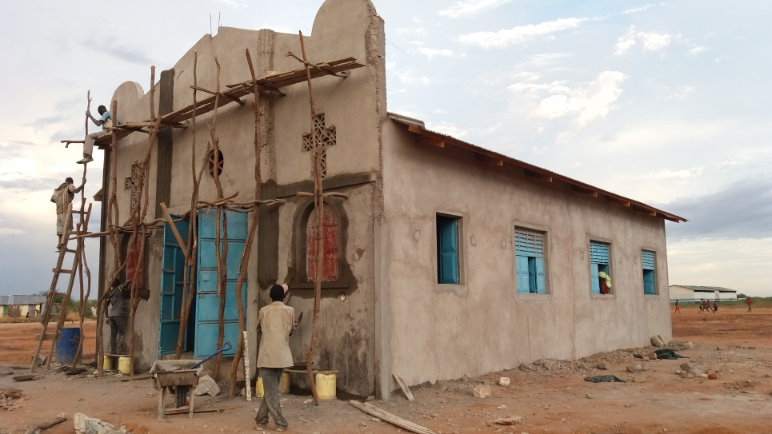
finishing work for the face of the church

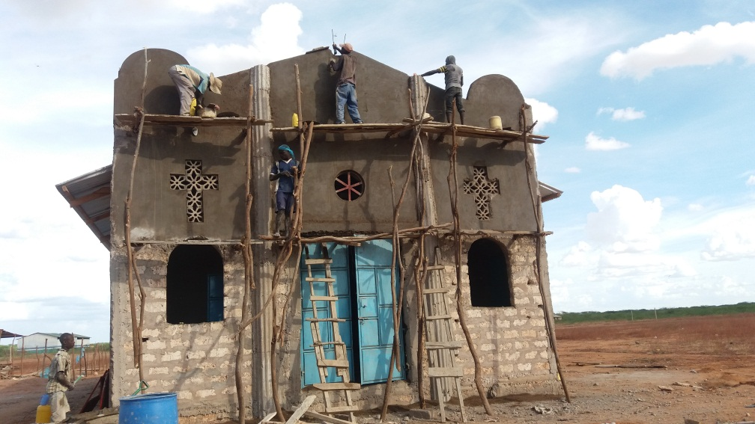

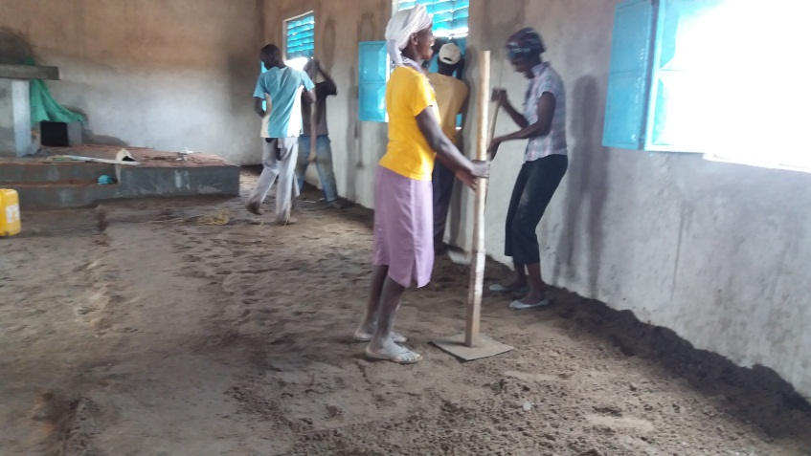
People form the community working in the floor of the church
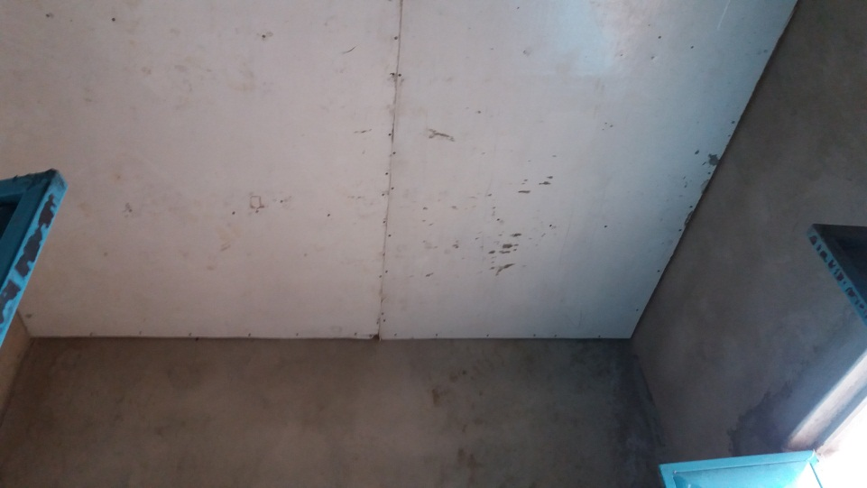
the ceiling covering for the sacristy and the store room

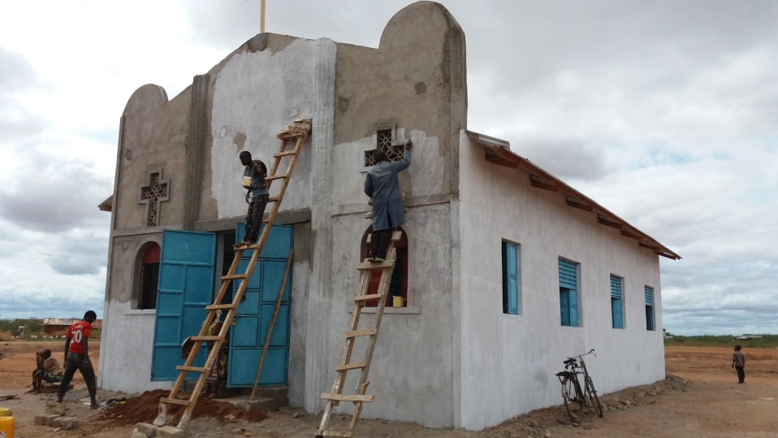
starting works o paint

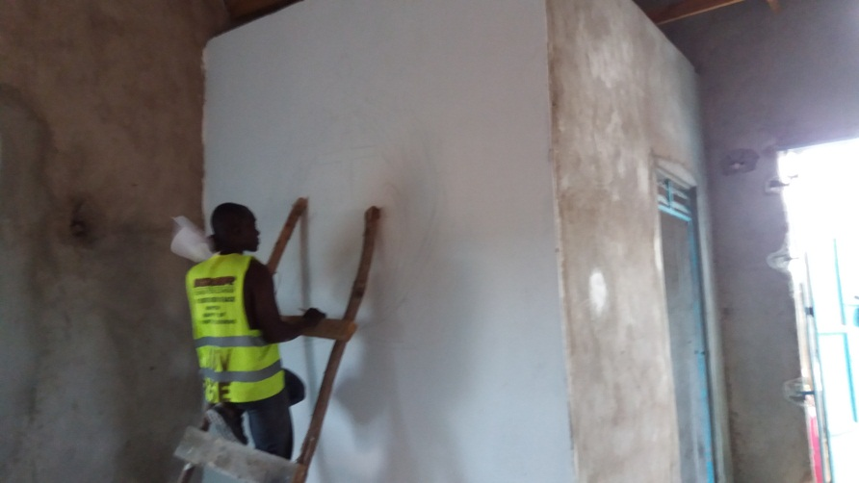
Painting the logo of Santina Foundation and the logo for the martyrs

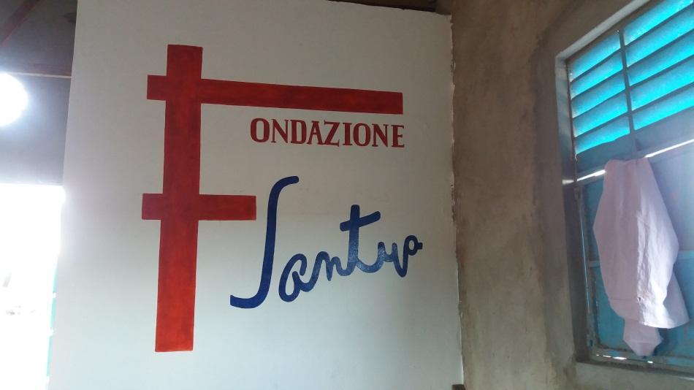
Logos in process of painting

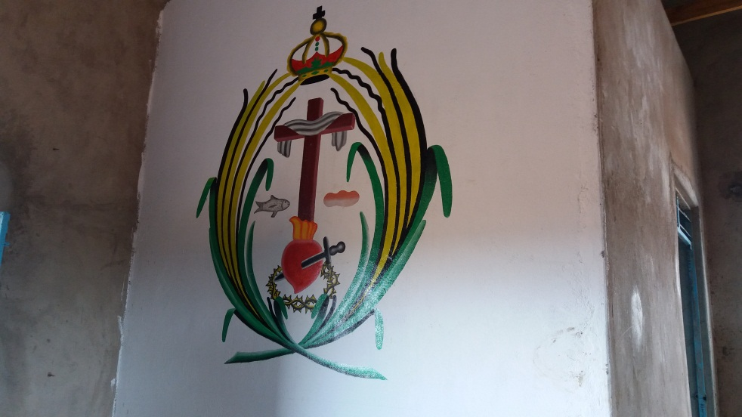

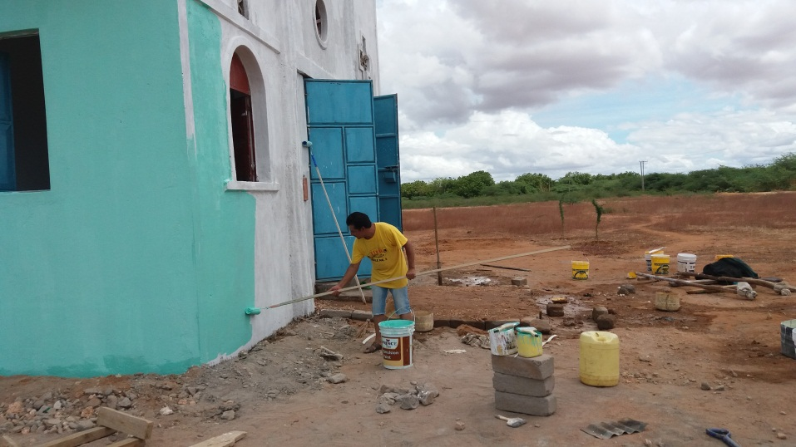

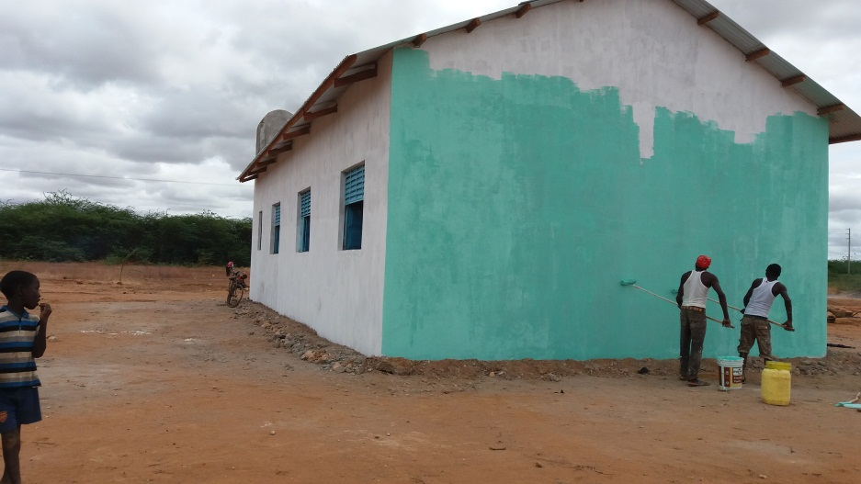

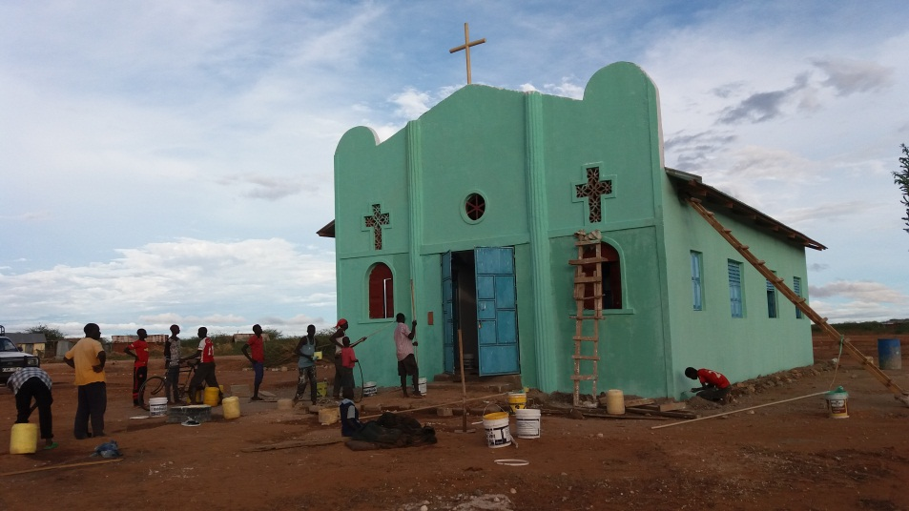

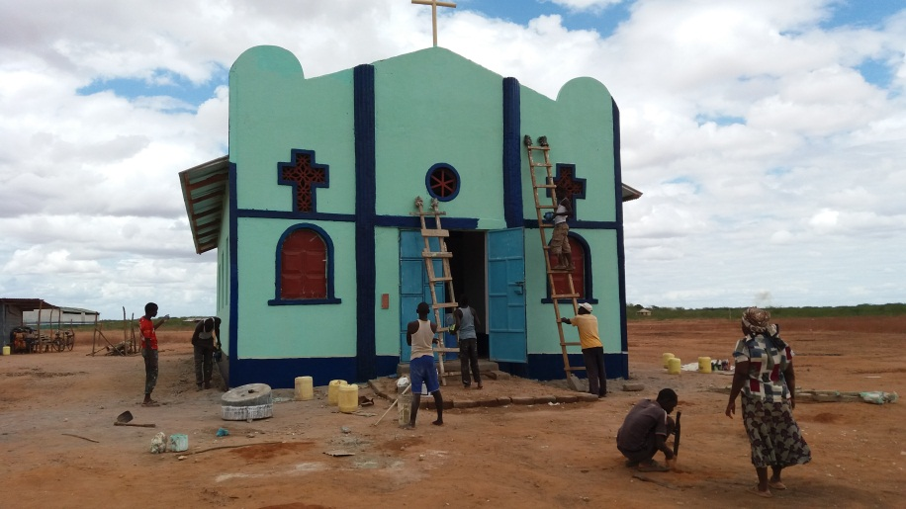

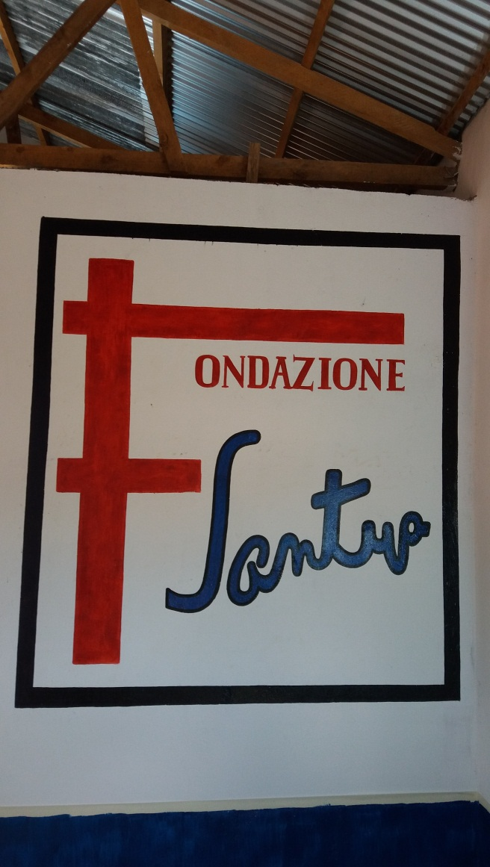
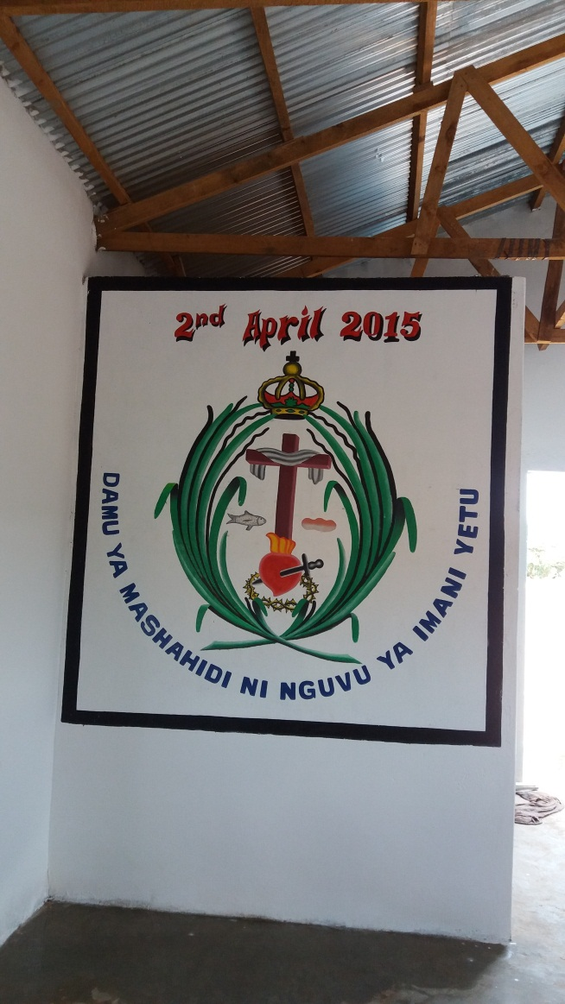

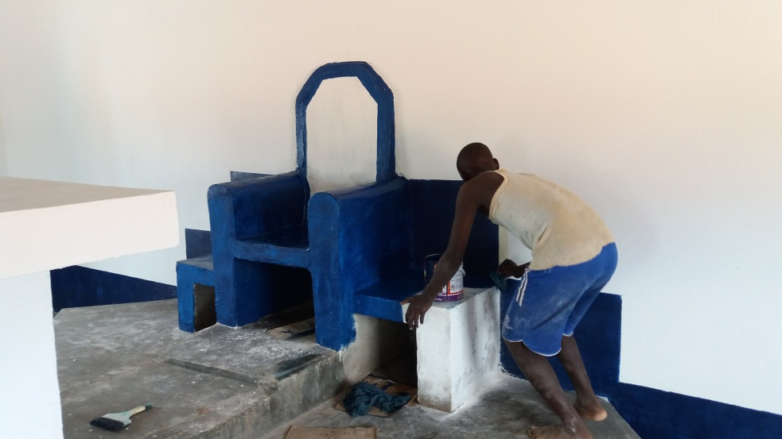

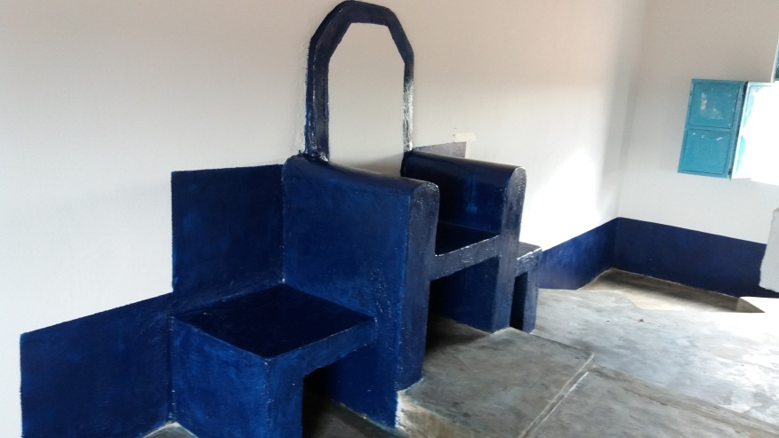

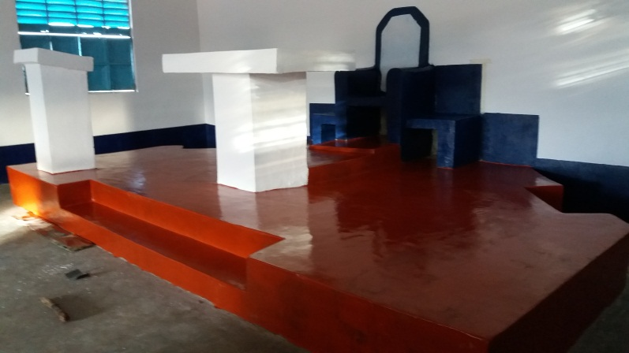

The sanctuary and the altar

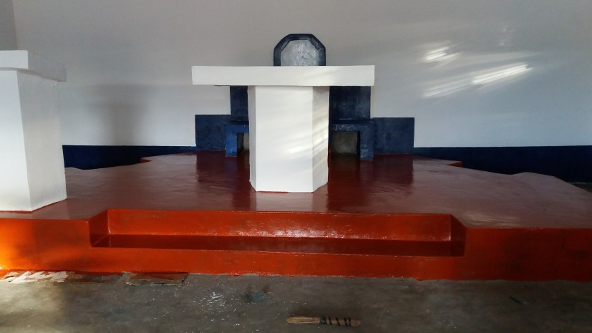

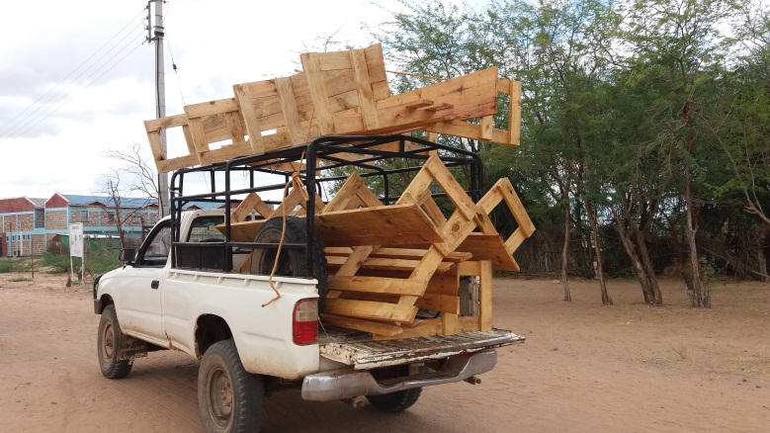

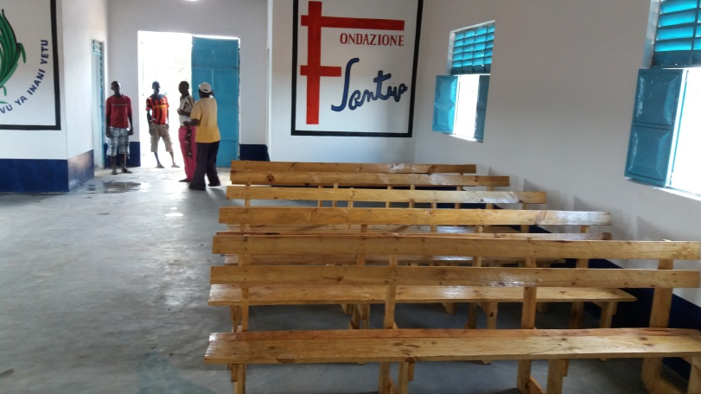

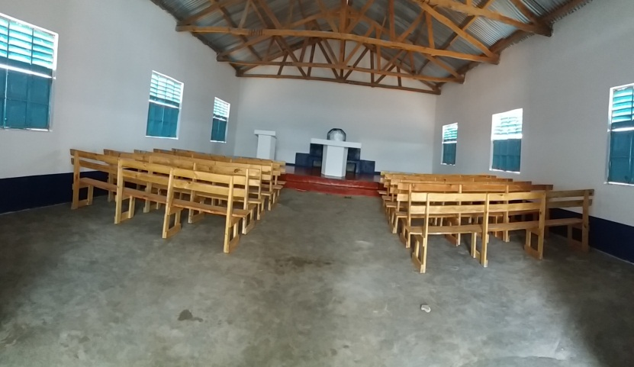
Our church constructed in memory of our martyrs in garissa 01 -05 2015, it is ready for the inauguration

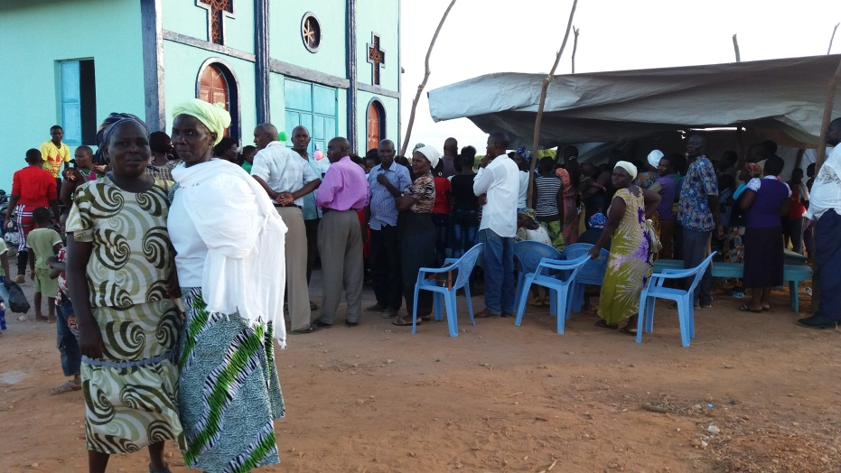
BIG INAUGURATION OF OUR NEW CHURCH AT ST. PAUL, BURA PARISH, CATHLOLIC DIOCES OF GARISSA.
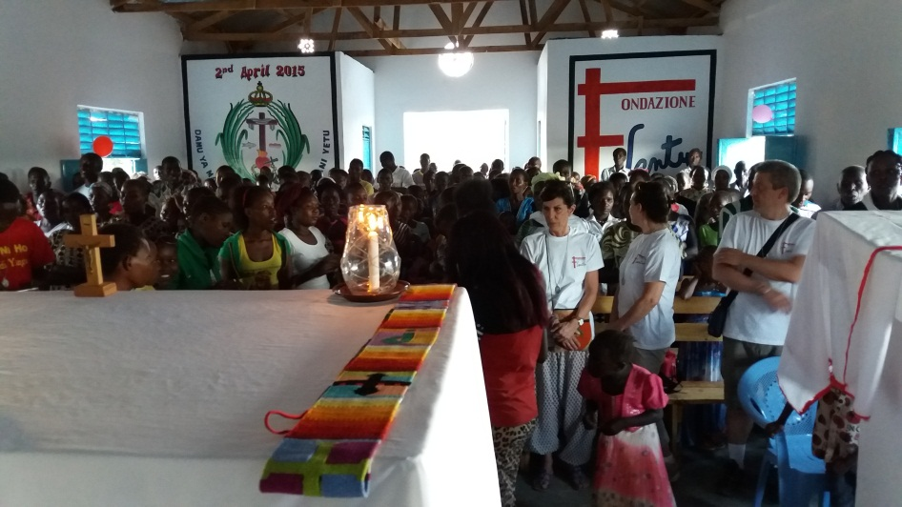
during the mass presided by FR. ALEJANDRO UMUL. Local moderator of the KENYAN MISSIONARY FRATERNITY OF MARY; With the presence of Emmanuel, Katherine, Marzia and MONS. LUIGI GINAMI. From Santina Foundation
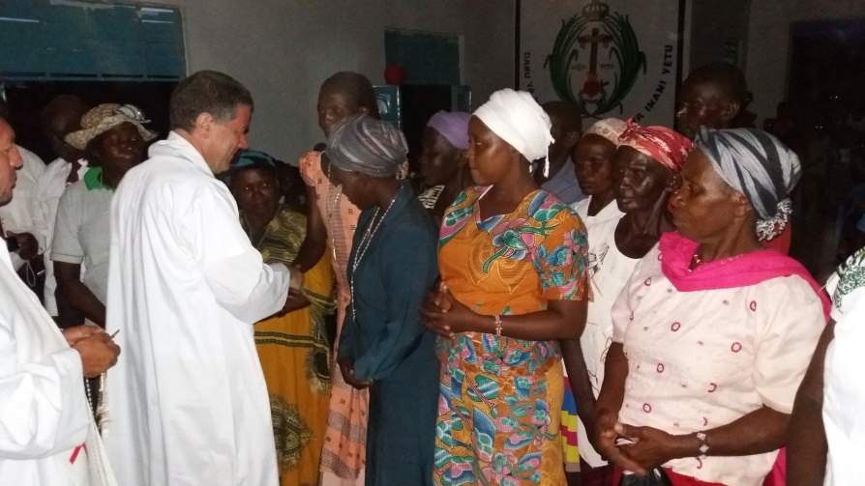
Mon senior Luigi, dressing rosaries to our local people.
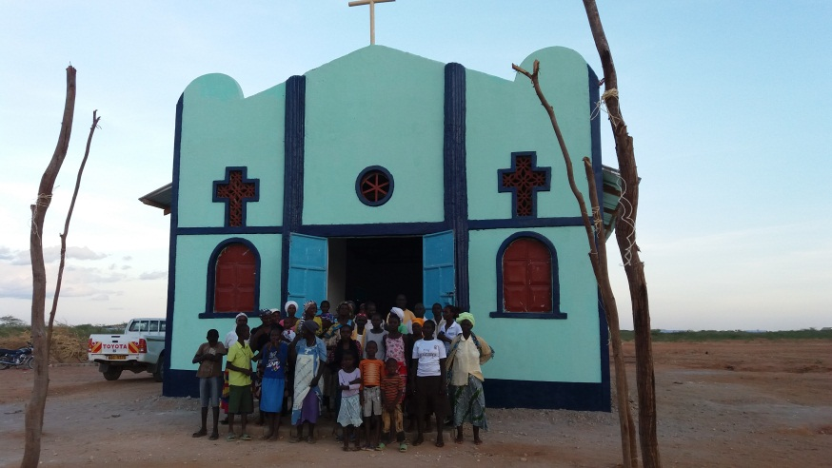
COMMUNITY OF ST. PAUL INTHEIR FIRST MASS, IN THE NEW CHURCH
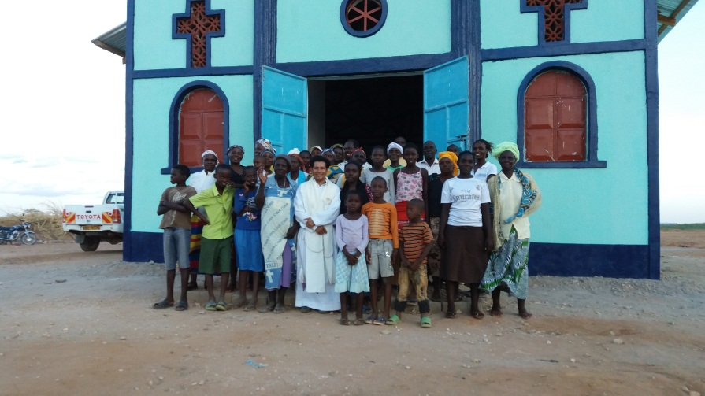
THANK YOU SO MUCH SANTINA FOUNDATION!
FONDAZIONE SANTINA, GRAZIE MILLE
ASANTE SANA SHIRIKA LA SANTINA
MUCHIsimas GRACIAS MI AMADA FUNDACION SANTINA
GOD BLESS YOU!

