BURA CATHOLIC MISSION
Diocese of Garissa
1ST SEMI-REPORT OF CHURCH CONSTRUCTION at ST. PAUL, VG. 10

Dear Sr./Md. Director “SANTINA FOUNDATION”
Receive greetings in the name of the Lord from Bura Catholic Parish.

Introduction:
Bura Catholic Parish it is located in the Diocese of Garissa northeast and cost province of Kenya. It is a try place almost desert, and in a environment 100% Muslim-Islamic. Where the Christian population we are 8%, from this 8% catholic population we are 2.5%.
The majority of our fellows, they are no local people, some teachers, soldiers, police officers , workers of the government and few business people. In the villages, our catholic fellows are farmers who have come from other regions of Kenya, (they are no locals).
Our location is 100 kms from the nearest city (Garissa) 245kms from Malindi city, and 600kms from Nairobi City (the capital of Kenya)
It is in this context where SANTINA FOUNDATION starts to do this mission helping to build a church for a community of this parish ( St. Paul village 10) on behalf of the fellows of this community, and the missionaries of Bura Tana, Kenya, I would like to express my gratitude for such a assistance to spread the gospel of Jesus Christ in an environment where, Christians are killed for the only fact of be a Christian.
Thanks Fr. Luigi Ginami, Santina Foundation, and all the donors for helping us to realize a dream among our people.
Following I give you the first report for the first part of the funds you sent to us.

The amount received was 4,000 euros. Equivalent 426,840.00 Kes. Expended by the following structure:

N0. | ITEMS |  | QUANTITY | AMOUNT | COMENTS
1 | Cement |  | 200 bags | 126,000.00
2 | wood | 3 x2 | 160 mts | 18,400.00
2 | wood | 4 x2 | 168 mts | 22,680.00
3 | iron sheets | 3 mts | 50 pcs | 35,000.00
3 | iron sheets | 2.5 mts | 50 pcs | 29,000.00
4 | iron bars | y 10 | 66 pcs | 38,610.00
4 | iron bars | R 6 | 35 pcs | 7,350.00
5 | coral stones |  | 1000 pcs | 80,000.00
6 | transport of materials |  |  | 48,000.00
7 | binding wire | 1 roll | 25 kg. | 3,750.00
8 | others (1st. payment labor charges) |  |  | 18,000.00 | total will be 200,000.00 kes
 | TOTAL EXPENSES |  |  | 426,790.00

FOLLOWING all THE receipt

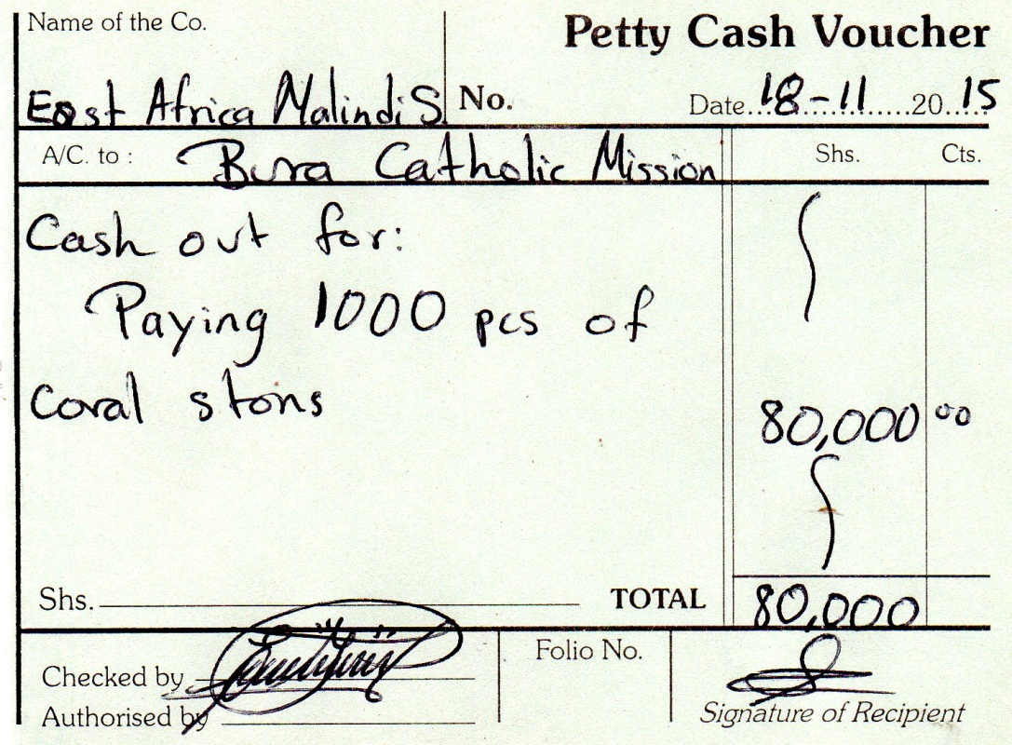
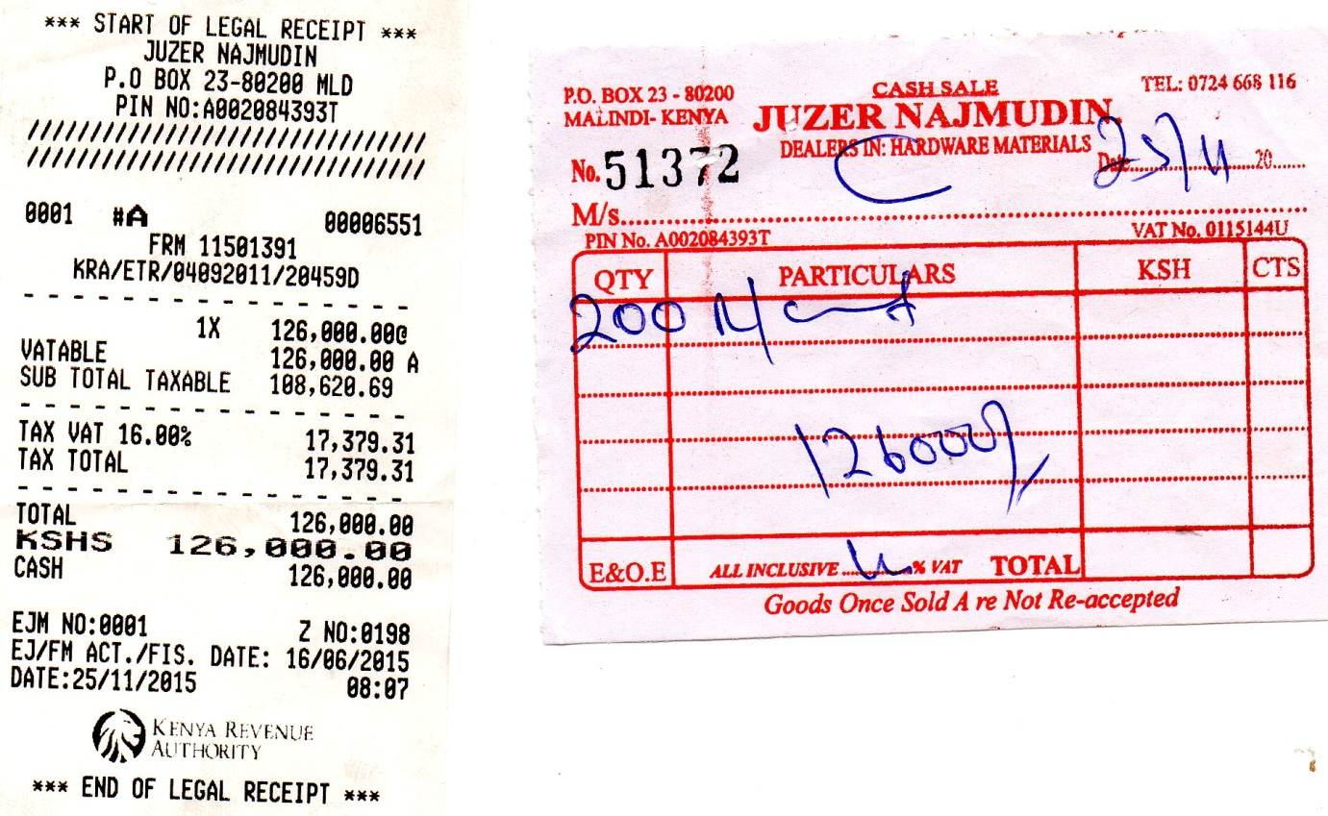
RECEIPT FOR 1000 pcs of coral stones, used for the basement or foundation,

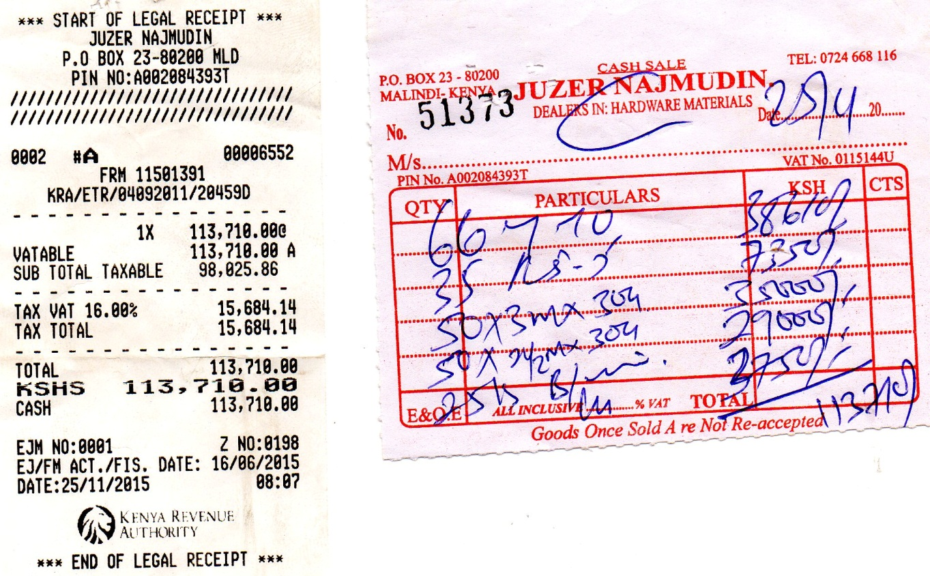
RECEIPT FOR IRON BARS, IRON SHEETS AND BINDING WIRE.
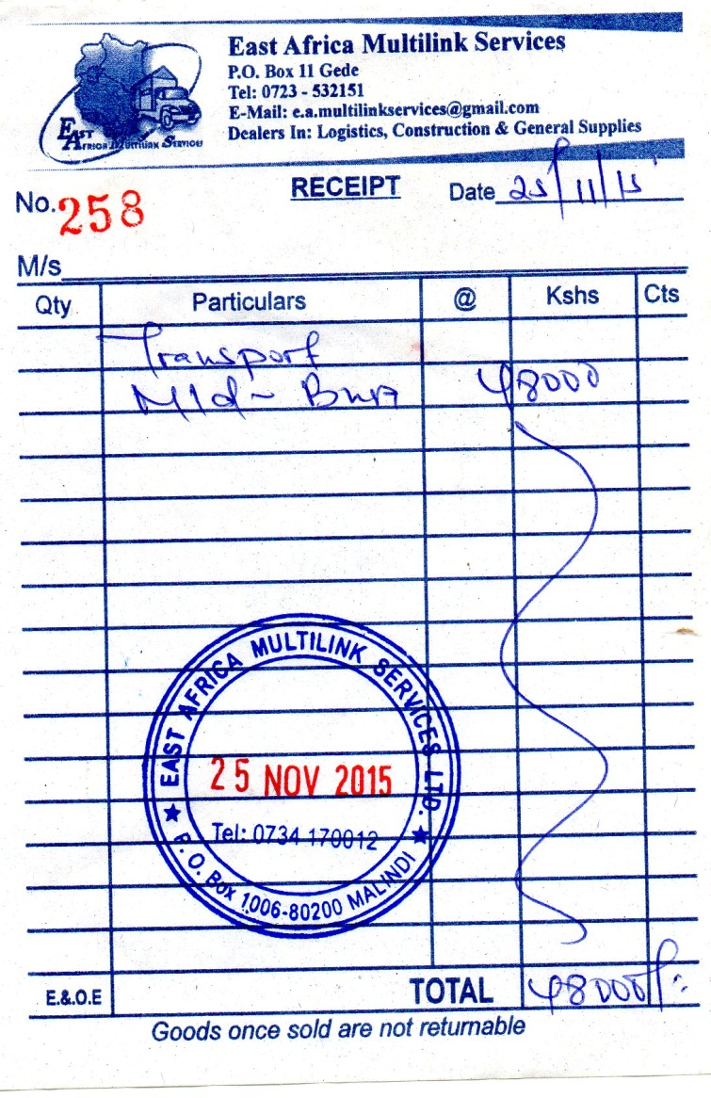

RECEIPT FOR TRANSPORT OF MATERIALS FROM MALINDI TO BURA.
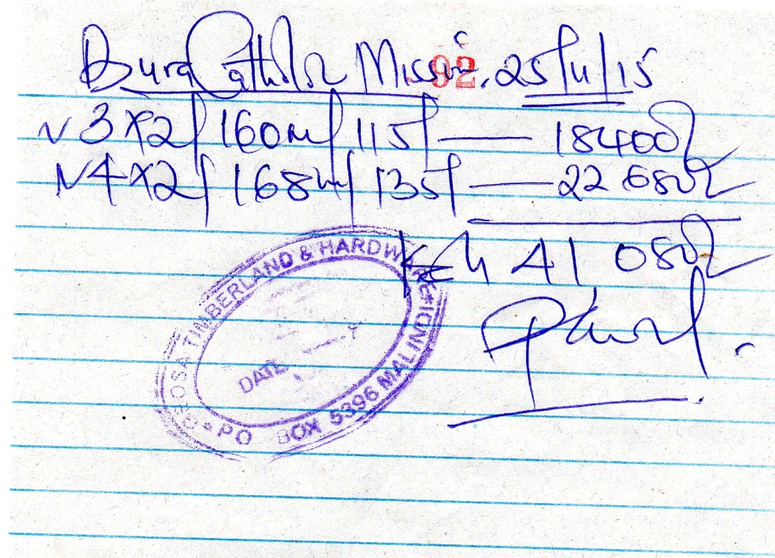
RECEIPT FOR WOOD: 3 X 2 AND 4 X 2, USING FOR ROOFFING STRUTURE

NOTE-_____________ labor charges, first payment ther is no recept becouse ther is one receipt for full payment of labor charges.
Also, the works have been continue without stop, the pictures I send to you in this report, it are the ones supporting the funds expended, in relation with the receipt I attached too.
HERE THE PICTURES.

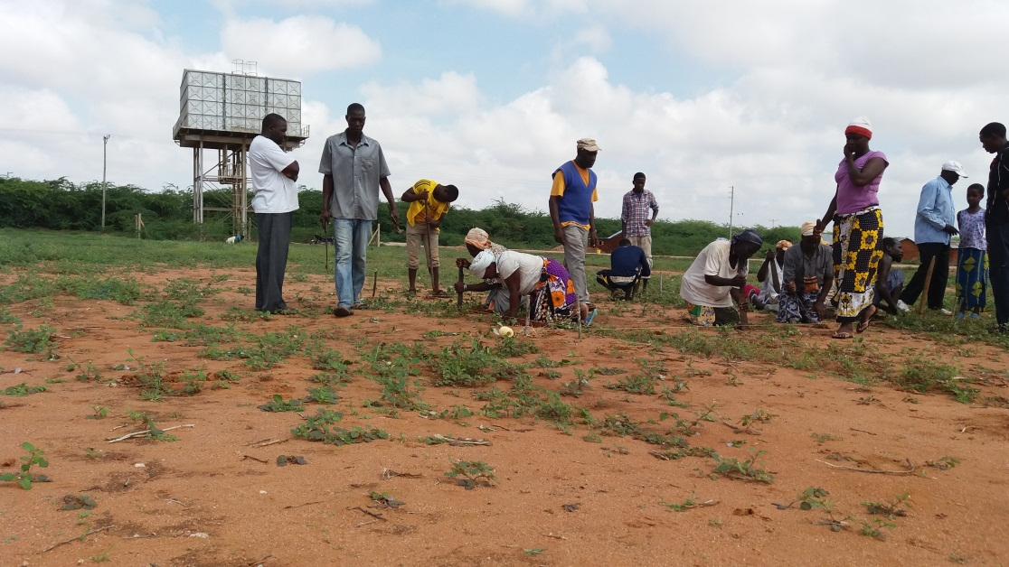
BUILDING A STORE FOR KEEPING ALL THE MATERIALS
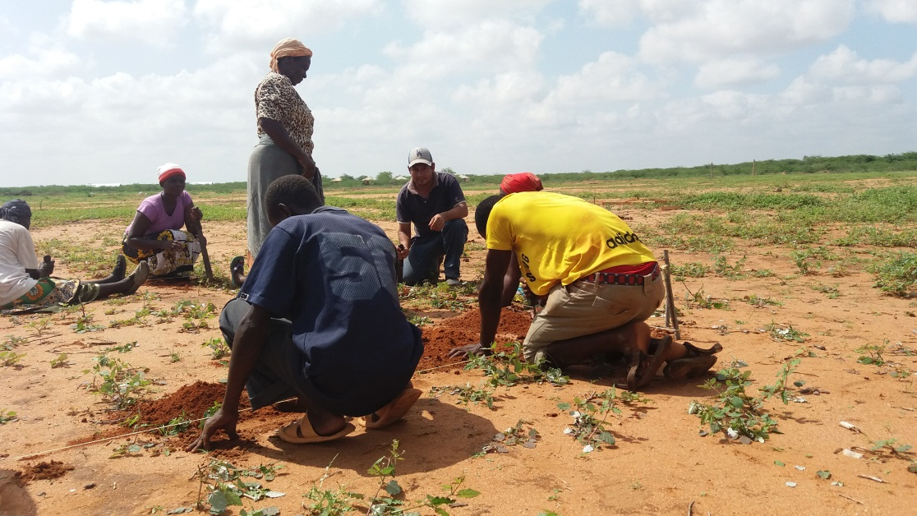

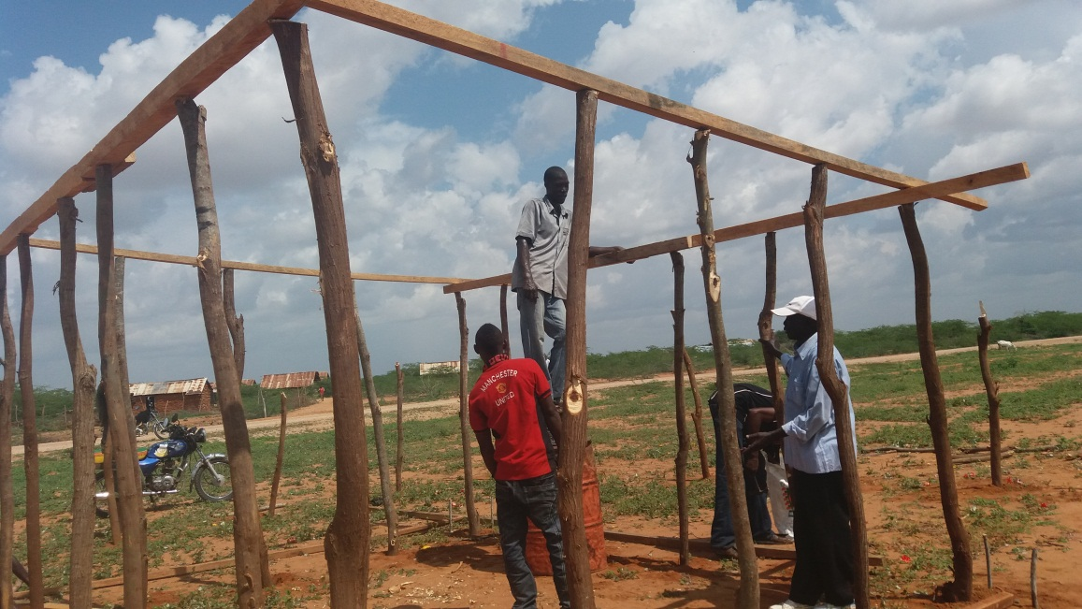

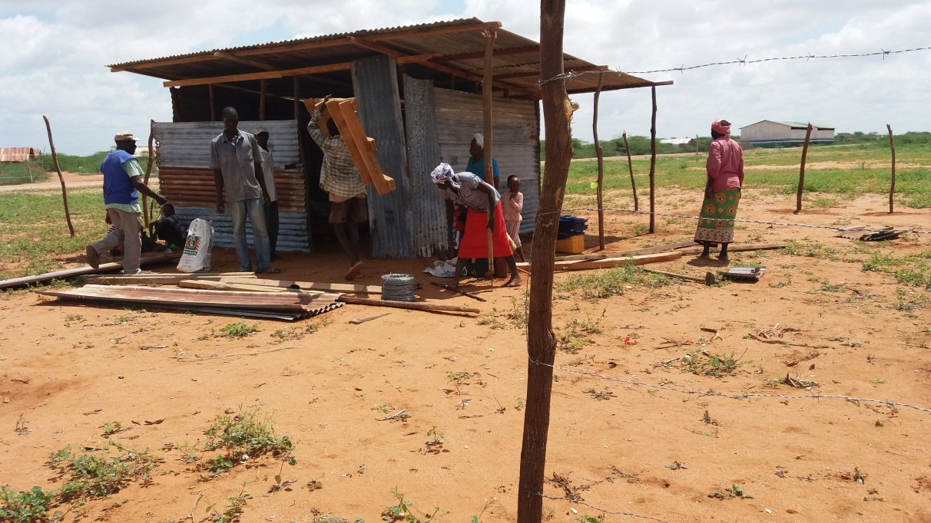

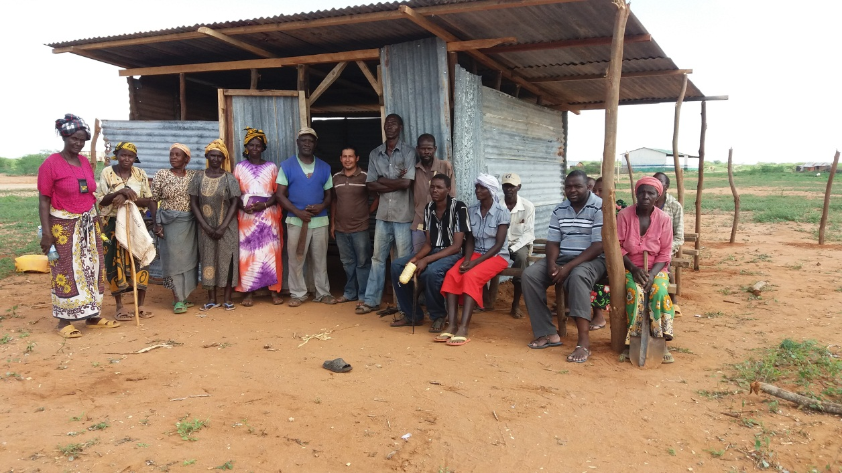
THIS IS FINILLY OUR STOR AN ALL THE PEOPLE THE COMMITE THEMSELVES TO BUILD THIS STORE
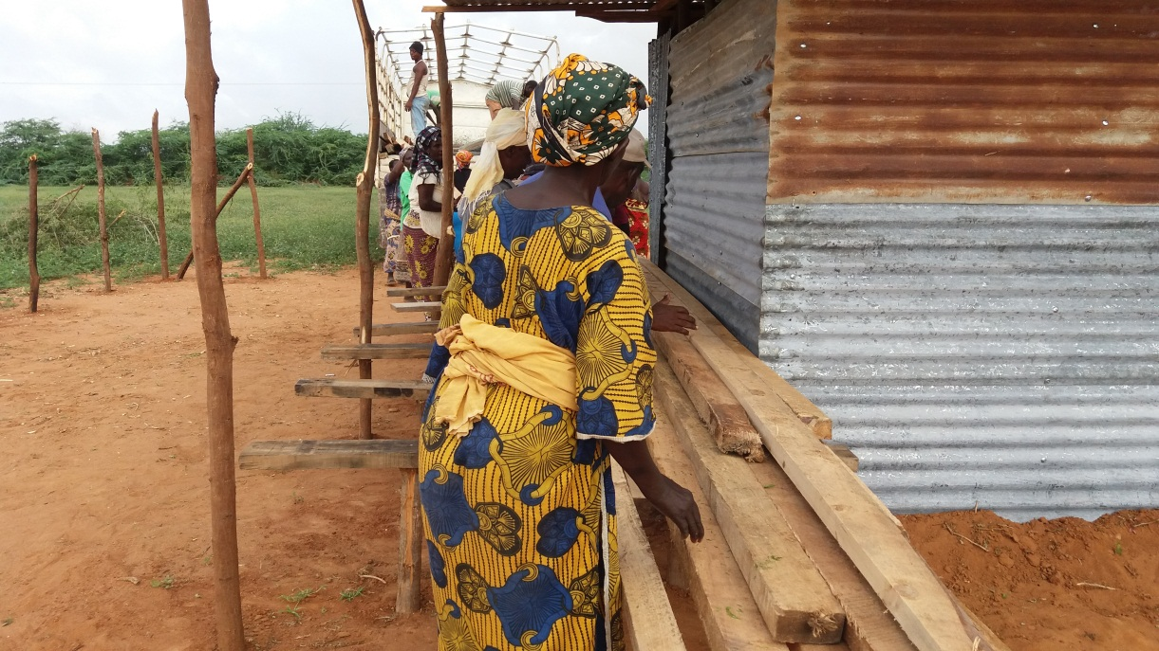
OUR FELLOWS TAKING DOWN THE WOOD FOR ROOFING
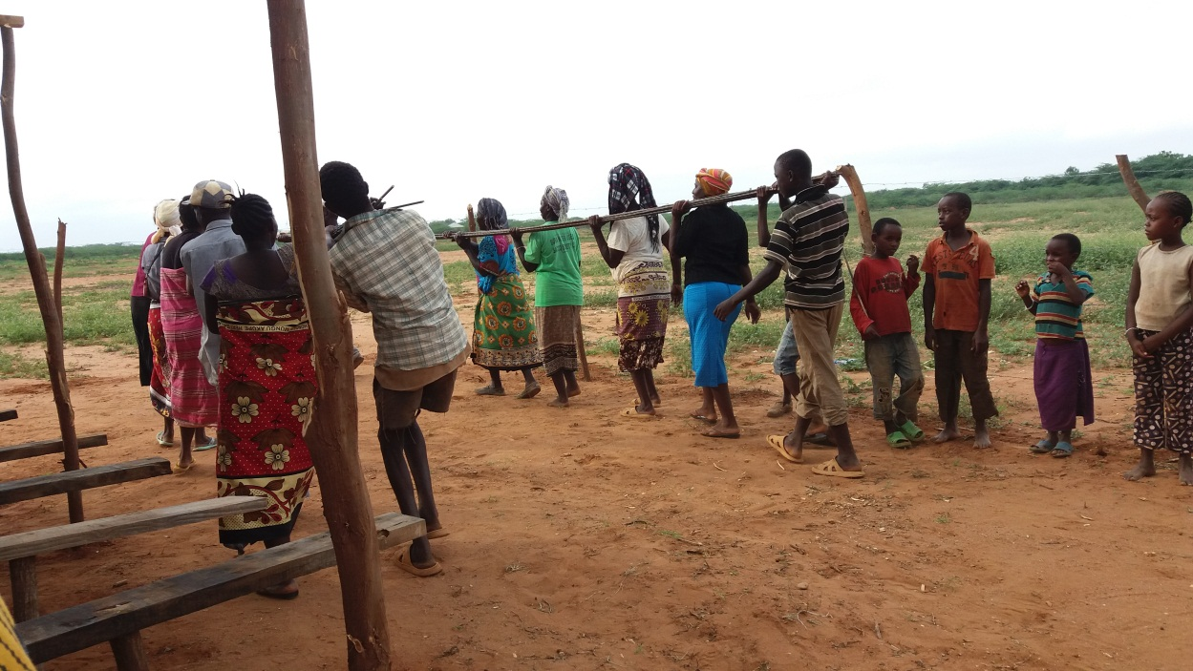
OUR FELLOWS TAKING DOWN THE IRON BARS
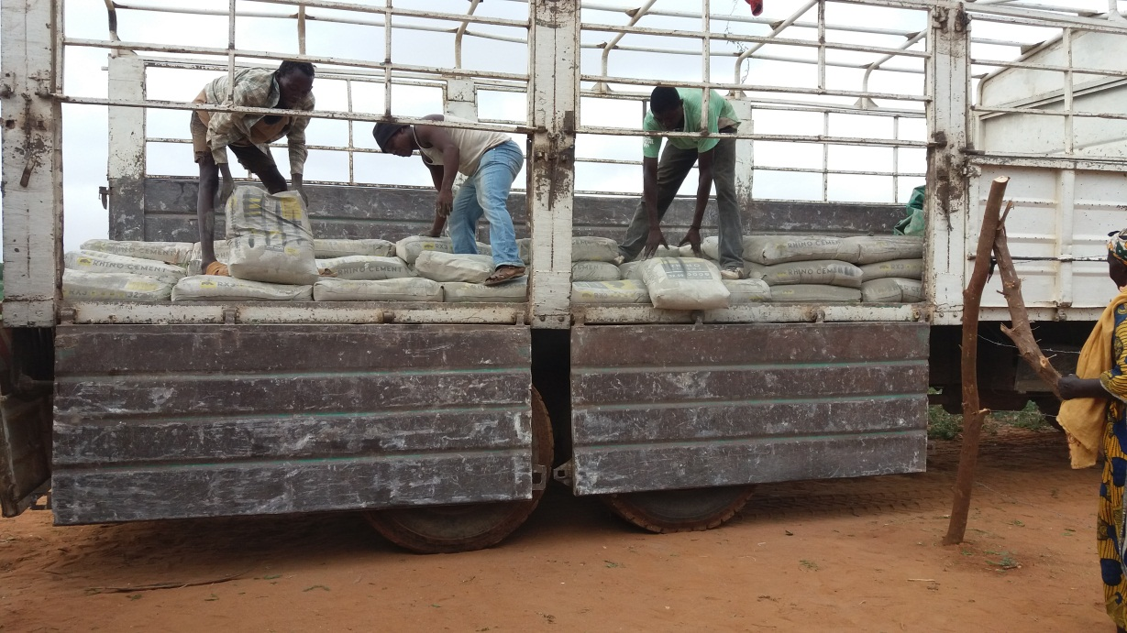
WORKERS AND FELLOWS TAKING DOWN CEMENT, 200 BAGS FOR NOW, WE WILL NIDD MORE THEN
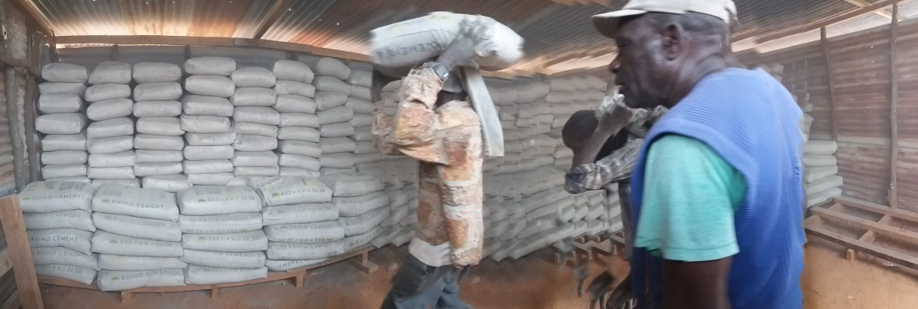
A MISSIONARY WORKING TOGETHER WITH HIS PEOPLE
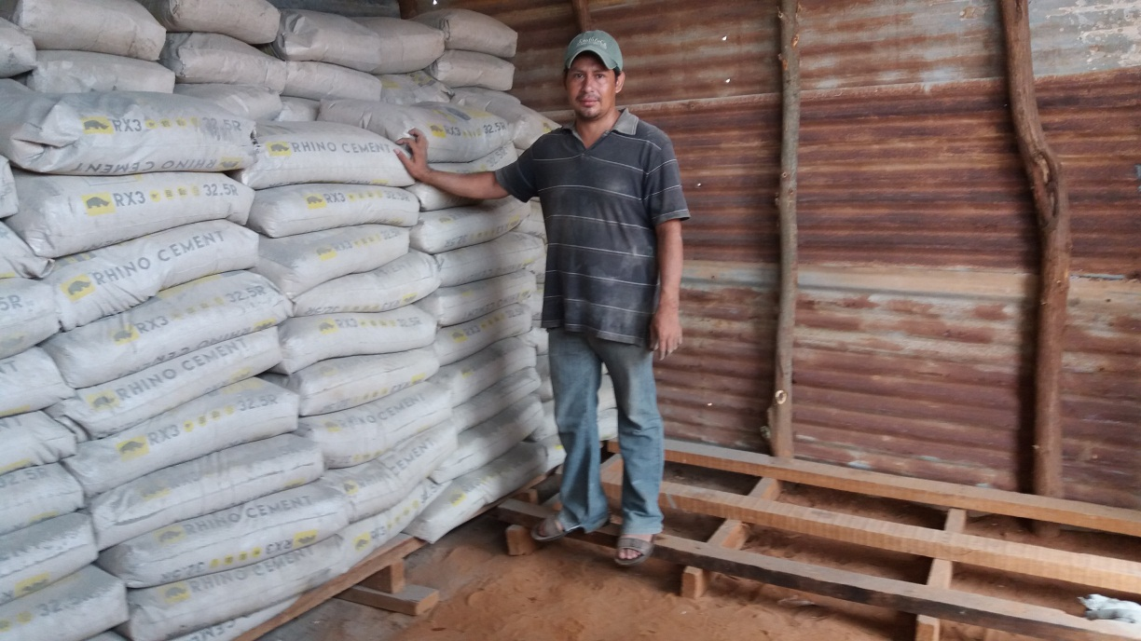

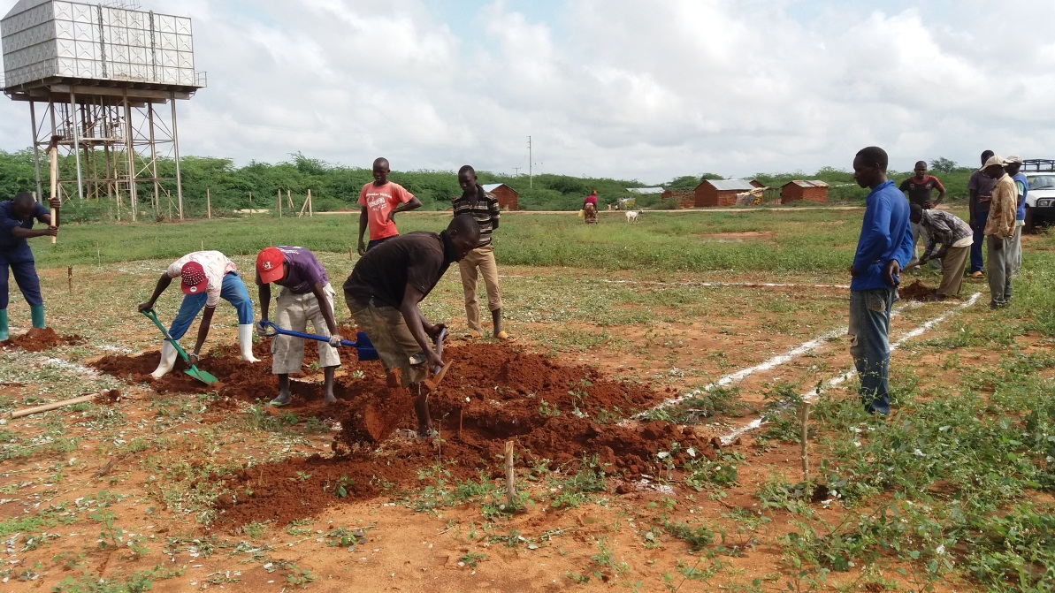
THE STARTING FOR THE CHURCH CONSTUCTION… WOW…. MORE THEN 30 PEOPLE CAME FOR WORK THIS DAY…. FR. GIGI, YOU AND YOUR FRIEND ARE DOING THIS EVANGELIZATION
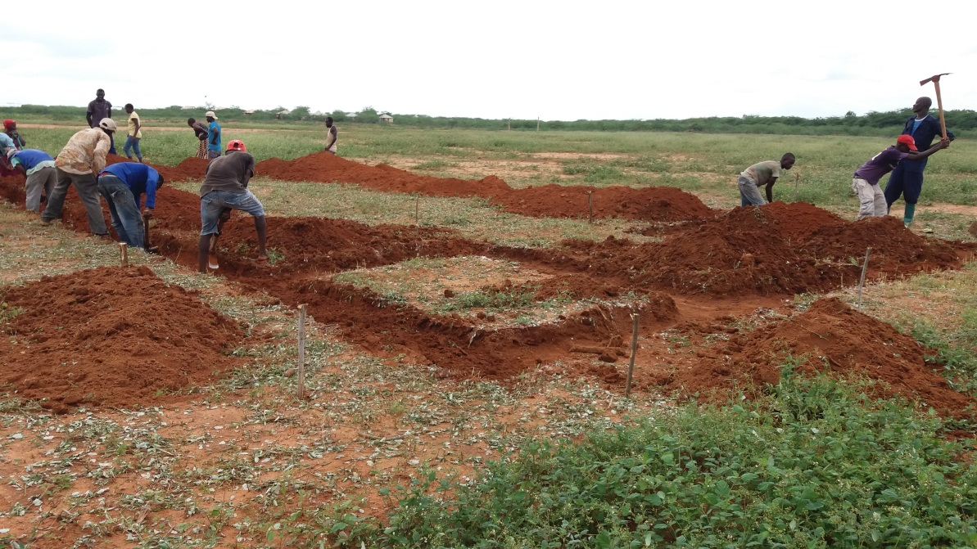

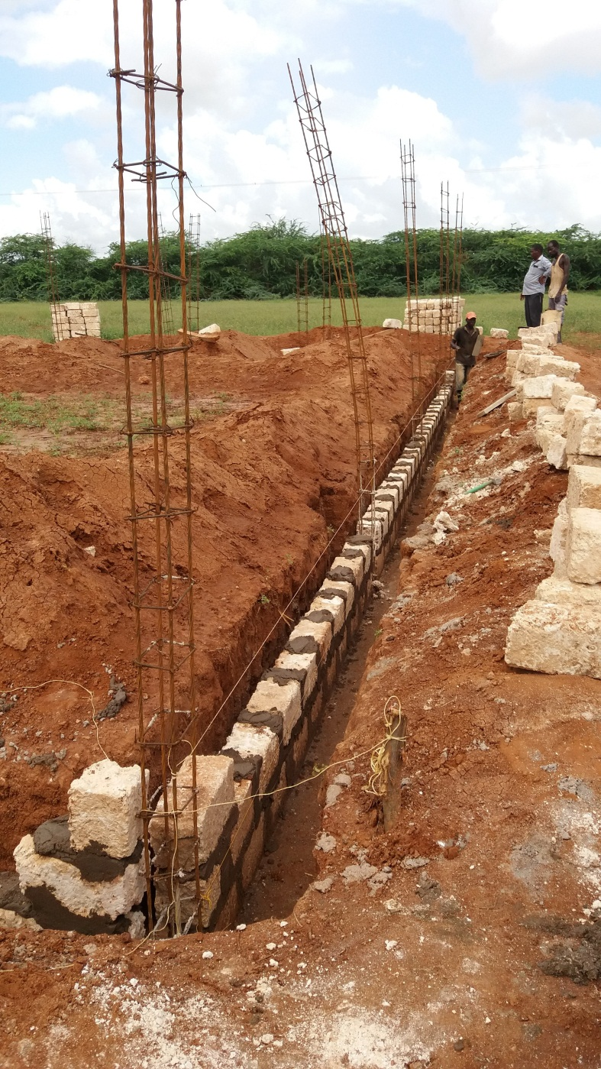
THIS IS THE CONSTRUCTION OF OUR CHURCH IN HONOR TO THE MARTIRS.
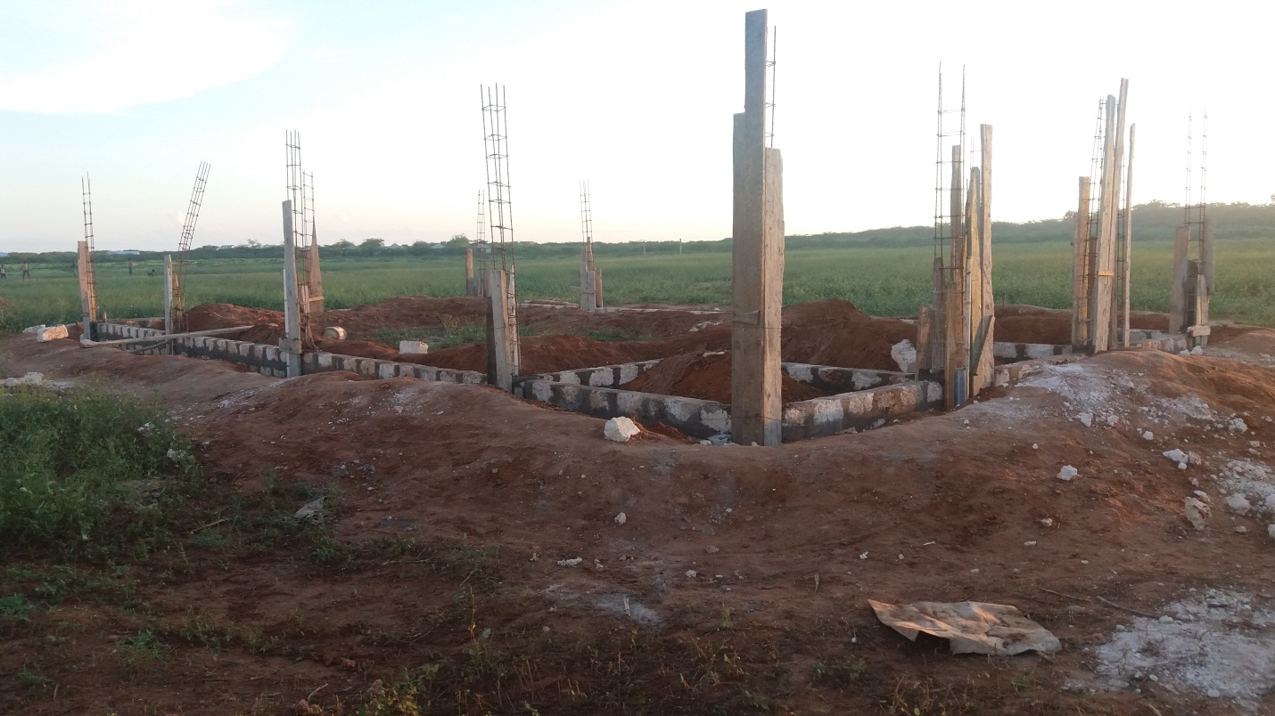
FUNDS REACH TO THIS POINT, BUT WE ARE GOING AHEAD WITH THE WORK.
Fr. Lugi, Santina Foundation, and all our Donors, we thank you for this support and for doing this mission with us… May God Bless you, and we hope to continue with this work of love.

Fr. Ernesto Contreras G. Fr. Julio Veliz A.
Parish pries. Assistent parish priest.

